Determination of Copper (II) by using 2,2/-[(1,1/-Biphenyl)-4,4/-diyl bis-(azo)]-bis-[4,5-diphenyl imidazole] ( Bbai )

Abid Allah M. Ali
College of Women Education, Department of Chemistry, Kufa University.
Dakhil N.Taha, Ahmed A. Alkurymy, Ahmed Saadon
College of Science, Departmentof Chemistry, Babylon University

(NJC)

(Received on 5 /8 /2007) (Accepted for publication 9/6 /2008)

Abstract
This research involve determination of Cu(II) by use a new reagent 2,2/-[(1,1/-Biphenyl)-4,4/-diyl bis-(azo)]-bis-[4,5-diphenyl imidazole] ( Bbai ), the wavelength of maximum absorption copper (Bbai) complexes at 588 nm
After optimum condition were constructed, Beer's law was obeyed in the range (0.4-2) ppm, the linearity ( R² ) was (0.9998), correlation factor (r) was (0.998) and molar absorpitivty (ε) was 4.1395x 10⁴ L.mol⁻¹.cm⁻¹.
The stoichometry of metal to reagent were (1:1), Precision and accuracy of the analytical procedure was R.S.D % (0.4) % and (E_{rel.} R_{e}) % were (-3.5, 96.5) %, detection limit was (0.03) ppm, the interferences of ions (CrO₄²⁻, Mn²⁺, Co²⁺, Ni²⁺, Zn²⁺, Cd²⁺ Ag⁺, Fe³⁺, Pb²⁺, Mg²⁺, Ca²⁺, Hg¹⁺, Hg²⁺) were study and masked by using sutable masking agents.
الخلاصة
يتضمن البحث تقدير النحاس الثنائي باستعمال الكاشف الجديد
2,2/-[(1,1/-Biphenyl)-4,4/-diyl bis-(azo)]-bis-[4,5-diphenyl imidazole] ( Bbai )
تبين ان اعلى امتصاص للمعقد كان عند الطول الموجي (588 nm) ، كما تم تحديد الظروف المثلى لتكوين المعقد، تم بناء منحني المعايره عند مدى من التراكيز تراوحت بين (0.4-2 ppm) حيث وجد ان الخطية (R²) مساويا الى (0.9998 ) و قيمة معامل الارتباط (0.998) اما قيمة معامل الامتصاص المولاري هي 4.1395x10⁴ L.mol⁻¹.cm⁻¹.
تم تحديد نسبة الفلز الى الكاشف حيث وجد انها تساوي (1:1) كما تم تحديد دقة وضبط الطريقة التحليلية حيث وجد ان قيمة R.S.D% (% 0.4 ), E_{rel.} (% 3.5-), R_{e} (% 96.5 ) , وجد ان حد الكشف 0.03 جزء بالمليون, درس تاثير الايونات المتداخلة التالية
(CrO₄²⁻, Mn²⁺, Co²⁺, Ni²⁺, Zn²⁺, Cd²⁺ Ag⁺, Fe³⁺, Pb²⁺, Mg²⁺, Ca²⁺, Hg¹⁺, Hg²⁺).
وحجبت باستخدام عوامل الحجب المناسبة

Introduction

Azo compounds are very important in the fields of dyes, pigments and advanced materials, many kinds of azo dyes have been synthesised, bis(hetaryl) derivatives are relatively rare.Unsymmetrical bis(hetaryl)azo dyes can be synthesized by the diazotisation of hetarylamines followed by acoupling reaction with heteroaromatic compounds⁽¹⁾. Mos the tarylamines can act as diazotisation components, hetaryl coupling components are limited, electron-rich heteroaromaticsubstr ates such as pyridones, imidazolones, thiophenes, thiazoles, and bithiazoles can act as coupling components⁽²⁻⁴⁾.Derivatives of mono- and bis-azochromotropic acid with pyrazole or imidazole as the heterocyclic diazocomponent belong to class of organic reagents that contain four nitrogen atoms coupled in conjugated system of π-bonds⁽⁵⁾. In contrast to great number of heterocyclic azo-dyes, such as 2-(2-pyridylazo)naphtol (PAN), 4-(2-pyridylazo)resorcinol (PAR), 4-(2-Tiazolylazo)resorcinol (TAR) and their derivatives, sulphonated azo-dyes have good solubility and stability in water, Besides, their spectral properties depend strongly on the media acidity, due to the protonation and dissociation of azo-group, heterocyclic >NH- and naphthalene -OH group⁽⁶⁻⁸⁾. Azo-dyes with the heterocyclic diazo-component form coloured complexes with many metal ions in solution,Great number of the spectrophotometric methods based on these reactions were developed and used in analytical chemistry^{(9,10)}. Heterocyclic azo-dyes usually react with the metal ions as tridentate legends forming coordinative bonds with heterocyclic moiety, -OH group and azo-group, the reactions between chromotropic acid derivatives with pyrazole or imidazole, as the heterocyclic diazo-component and Pd(II) are very sensitive and selective⁽⁵⁾. Azo-dyes compounds used to determination some metals, for examples Gao determined Cu²⁺ and Co²⁺, a method for selective determination of copper(II) based on the reactions of Cu²⁺ or Co²⁺ with 3-[(o-carboxy-nitrobenzene)azo]chromotropic acid (CNBAC) at pH = 11.4 was developed, results have shown that two complexes, Co(CNBAC)₂ and Cu(CNBAC), were formed, whose cumulative stability constants were 5.22 x 10⁹ and 7.61 x 10⁵ dm³ mol⁻¹, respectively, and their molar absorption coefficients were 1.19 x10⁴ and 2.12 x10⁴ dm³ mol⁻¹ cm⁻¹ at 610 nm⁽¹¹⁾. Zenki et al determined Zn²⁺ with 2-(5-Bromo-2-pyridylazo)-5-[N-n-propyl-N-(3-sulfopropyl)amino]phenol (5-Br-PAPS), by using cyclic flow injection analysis technique, the detection limit of this methods was 0.02 mg dm⁻³ at 552 nm⁽¹²⁾.Copper is a mineral that occurs naturally in many foods, including vegetables, legumes, nuts, grains and fruits, as well as shellfish, avocado, and beef organs such as liver⁽¹³⁻¹⁵⁾. This work aimed to determination of copper (II) by using a new diazo compound 2,2/-[(1,1/-Biphenyl)-4,4/-diyl bis-(azo)]-bis-[4,5-diphenyl imidazole] ( Bbai ).
Experimental
Apparatus
A model UV-Probe spectrophotometer (Schematize-Germany) and model 21spectrophotometer single beam with 1 cm cells (Bausch & Lomb-USA) was used for all absorbance measurements, pH measurements were made with a model Knick-Digital pH meter (England), Digital Balance, Sartorus, (BP,3015- Germany), Water bath, Gesellschaft Fur Labortechnik (Germany) , FT-IR 8400S Schimadzu (Japan) was used to obtain I.R spectra and CHN elemental analyzer 1108 were used.

Reagents
All chemicals were used of analytical – reagent grade unless other wise stated, all solutions were prepared using de-ionized water.
Copper solution (100 ppm) was prepared by dissolving (0.0268 g) of CuCl₂.2H₂O in 100 ml distilled water.
Bbai solution (1x10⁻³ M) was prepared by dissolving (0.0299g) of pure reagent in 50 ml of absolute ethanol, working solutions were prepared freshly appropriate dilution of the stock solution.
Synthesis of Bbai
The diazo dye ligand ( Bbai ) was prepared following the procedure as describe for the 2-(aryl azo) imidazoles⁽¹⁶⁾.The tetrazonium solution was prepared by dissolving (1.8400g, 0.01mol) of binzidene in 50 ml of water and 4 ml of concentrated hydrochloric acid.The solution was treated with 8 ml of aqueous (1M) sodium nitrite dropwise, and stirred for 30 min. at 0 ºC, 4,5-diphenyl imidazole (2.2000g, 0.02 mol) was dissolved in 200 ml of ethanol, and 80 ml of 10% sodium hydroxide was added, the tetrazonium chloride solution prepared above was then added dropwise for coupling after the mixture had been stirred for 3h at 0-5 ºC, it was acidified with dilute hydrochloric acid until (pH=5).The precipitated was filtered, air dried and recrystallized twice from hot ethanol and then dried in the oven at 100 ºC for two hours, m.p. (140-142 ºC), C.H.N values are show in table (1)

Table(1) C.H.N values of the reagent (Bbai)
 | C% | H% | N%
Theoretical value | 78.01 | 4.64 | 17.33
Practical value | 78.15 | 4.56 | 17.19

General procedure
Into a 5 ml calibrated flask, transfer (0.5 ml) of sample solution containing not more than 0.5 ml (5 ppm) of Cu²⁺ and (0.5 ml) of 1x10⁻⁴ M ethanolic (Bbai) solution and dilute to volume with distilled water, mix well and after 10 min measure the absorbance at 588 nm in a 1 cm cell against a reagent blank prepared in a similar way but without Cu²⁺ in all experiments.

Results & Discussion

Physical and chemical properties of (Bbai)
The reagent is a reddish brown powder which is sparingly soluble in water. It is soluble in most organic solvents such as ethanol, methanol, acetone, chloroform and ether. It is red in alkaline solution, yellow in weakly and strong acidic solution.

Effect of pH

The effect of pH on the absorbance value of the complex was studied, figure (1) show this effect

Fig. (1) Effect of pH on the absorbance of the complex at room temp.

Figure (1) demonstrated that the absorbance of the complex in the range (4-6) and a pH (5) was adopted, the decrease in absorbance at pH value below (4) is due to formation azolium cation, while pH higher than (6) has cause a decrease in the absorbance due to the formation of Cu (OH)₂ .

Stability of the chromogenic system with time
Stability of the chromogenic system with time is shown in figure (2).

Fig.(2) Effect of time on the absorbance of the complex at room temp.

This Figure show that the complex system reaches a maximum value of absorbance with in (5) min. and remains constant up to (24) hrs.

Effect of temperature.

The effect of temperature in the range (5 – 60 ºc)on the absorbance of copper (Bbai) complex was studied figure (3) show this effect.

Fig.(3) Effect of temperature on the absorbance of copper complex.

The study was performed at temperature between 5 ºC and 60 ºC, a maximum absorption was obtained at temperature 10 ºC for the complex, after this temperature the absorbance of complex was decrease due to dissociation of the complex and the colure of complex was decrease .
Composition of the complexes
The composition of complex was evaluated by continuous variation and mole ratio methods were showed in figures (4&5).

Vm/Vm+Vl

Fig.(4) Continuous variation method for copper (Bbai) complex at optimum condition.

Fig.(5) Mole ratio method for copper (Bbai) complex at optimum condition.

Continuous variation and mole ratio method in figures (4&5) proved that the ratio between copper to (Bbai) is (1:1) and the stability constant⁽¹⁷⁾ is 3.2 x 10⁶ L.mol⁻¹.

Figure (6) shows the composition of complex

Fig. (6) The composition of Cu (Bbai) complex
Calibration curve
Calibration curve was obeyed in the concentration between (0.4-2) ppm, this relation was shown in figure (7).

Fig.(7) Calibration Curve for Copper(II).

Beer's law was obeyed in the range (0.4-2) ppm, the linearity ( R² ) was (0.9998) and molar absorpitivty (ε) was 4.1395x 10⁴ L.mol⁻¹.cm⁻¹.
Precision and accuracy of the analytical procedure was R.S.D % (0.4) % and (E_{rel.} R_{e}) % were (-3.5, 96.5) %, and the detection limit was (0.03) ppm
Interferences
The selectivity of copper (Bbai) complex was tested by carrying out of determination of 1x10⁻⁴ M of copper at optimum conditions in presence of foreign ions, these ions are reacts with (Bbai) during it's reaction with Cu²⁺, table (2) show effect of interference ions⁽¹⁸⁾.

Table (2) Effect of interference ions
Interference ions | Concentration (M) | Interferences
Cd²⁺ | 5x10⁻⁴ | +14.2
Co²⁺ | 5x10⁻⁴ | +3.1
Ni²⁺ | 5x10⁻⁴ | +10.1
Zn²⁺ | 5x10⁻⁴ | +15.2
Mn²⁺ | 5x10⁻⁴ | +9.5
Ag¹⁺ | 5x10⁻⁴ | +2.4
Cr³⁺ | 5x10⁻⁴ | +7.4
Cr⁶⁺ | 5x10⁻⁴ | +12.3
Fe³⁺ | 5x10⁻⁴ | +1.5
Pb²⁺ | 5x10⁻⁴ | +5.4
Mg²⁺ | 5x10⁻⁴ | +8.3
Ca²⁺ | 5x10⁻⁴ | +5.5
Hg¹⁺ | 5x10⁻⁴ | +6.3
Hg²⁺ | 5x10⁻⁴ | +3.7

Effect of masking agents⁽¹⁹⁾
The effect of masking agents was studied to increase the selectivity of complexes, four masking agents were used (Tartaric, Oxalic, Citric and Ascorbic acid).
Experiments showed that the citric acid was a better masking agent for the interferences .
Absorption spectra
The absorption spectra of the complex and the ligand are shows in figure (8) under optimum conditions

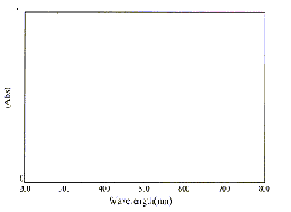
Complex
L
fig.(8) Absorption spectra of complex and ligand.

Absorption spectra show the λ max of ligand is clear at 500 nm and Cu (Bbai) complex at 588 nm this mean red shift and complex formation.
FT-IR spectrum of ligand
A construction of ligand proved by using FTIR technique, fig.(9) shown the maximum absorption of each group.

Figure (9) FT-IR spectrum of ligand.
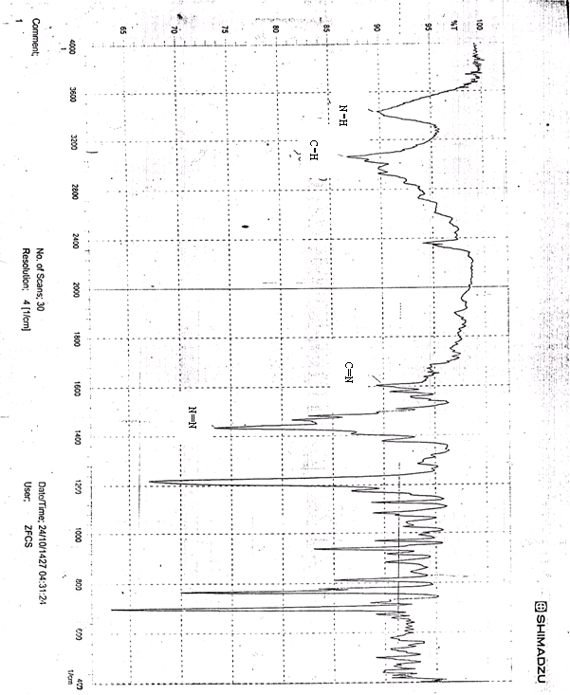

FT-IR spectrum of complex
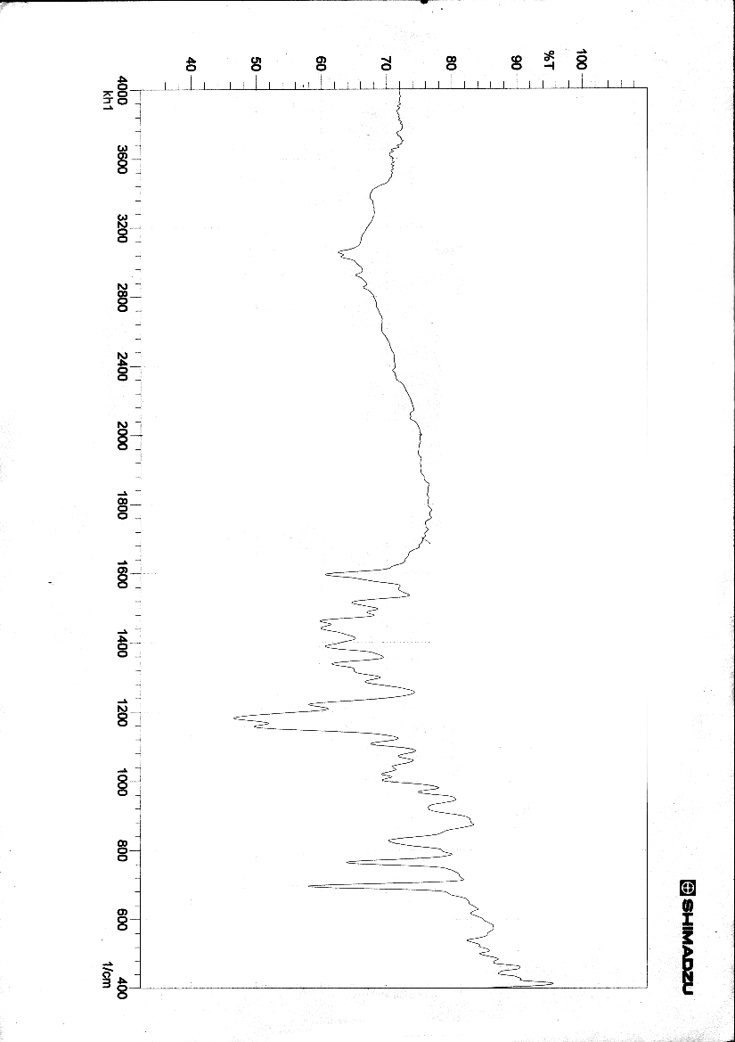
(N-H)
(C-H)
(C=N)

Figure (10) FT-IR spectrum of complex

From fig.(10) give an evidence for the formation of the complex where the absorption bands positions of (N-H, C-H and C=N)⁽²⁰⁾ still not change but the change in the shape and intensity due to the coordination of nitrogen atoms in imidazol rings with copper (II) ions.
A sharp band of (-N=N-) appeared at (1435) cm⁻¹ in the ligand but in the complex appeared at (1462) cm⁻¹ due to the coordination process⁽²¹⁾.
A strong band at (696) cm⁻¹ in the ligand referred to the phenyl groups that is substituted on the imidazol rings still in the same position and not change when compared with complex spectrum.

References
- D.R Waring & G. Hallas , The chemistry and application dyes. New York: Plenum; (1990).
- N. Ertan & F Eyduran, Dyes and Pigm, 1995, 27, 313.
- N. Ertan, Dyes and Pigm, 2000, 44, 41
- R. Flaig & H. Hartmann, J Heterocyclic Chem, 1997, 34, 1291.
- J. Savic & V. Vasic, Acta Chim. Slov., 2006, 53, 36.
- S.B. Sonowale, Y.V. Ghalsasi & A.P. Argekar, The Jap. Soc. Anal. Chem., 2001, 17, 285.
- M. Torre & M. L. Marina, Crit. Reviews Analyt. Chem., 1994, 24, 327.
- M. Wang, K. Funabiki & M. Matsui, Dyes and Pigments, 2003, 57, 77.
- S. B. Savvin, V. P. Dedkova & O. P. Shvoeva, Russ. Chem. Rev., 2000, 69, 187.
- S. A. Morozko & V. M. Ivanov, Zh.Anal.Khim., 1996, 51, 631.
- H. Gao & J. Zhao, Croatica Chemical Acta, 2003, 76 (1), 1.
- M. Zenki, Y. Lwadou, T. Yokoyhama, Analytical Sciences, 2005, 21, 517.
- L.S.Jensen, J. Nutr., 1975, 105(6), 769
- M.N. Khan & A. Sarwar, Anal. Science, 2001, 17(10), 1195.
- M.J. Ahmed, I. Jahan & S. Bano, Anal. Science, 2002, 18(7), 805.
- S. Shibata, M. Furukawa & R. Nakashima, Anal. Chem. Acta., 1976, 81, 131.
- W.C. Vosburgh & G.R. Cooper, J. Am. Chem. Soc., 1941, 63, 437.
- H. Shuker, M.Sc. Thesis, Mosul University, (1992).
- W. Abd Al-Azezz, Ph.D.Thesis, Mosul University, (1990).
- F.N. Al-Obaidi, Ph.D Thesis, University College of North Wales, Bager, (1981).
- P. Byabartta, S. Pal, T. Misra, C. Sinha, F. Liao, K.P. Selvan & T.H. Lu, J. Coord. Chem., 2002, 55, 479.

