Synthesis and Characterization of Some New 1,3,4-Thiadiazol Derivatives

Ikbal S. Al-Shibani, Nejlaa K. E. Al-Yonis and Amar H. Al-Dujaili
Department of Chemistry, College of Education, Ibn Al-Haitham, University of Baghdad, Baghdad, Iraq

(NJC)

(Received on 22 /5 /2005) (Accepted for publication on 4 / 3 /2006)

Abstract
Fifteen compounds of 2-amino-5-mercapto-1,3,4-thiadiazole derivatives were synthesized and classified into three groups A, B and C. Group A compounds were prepared by condensation reaction of 2-amino-5-mercapto-1,3,4-thiadiazole with some para substituted benzaldehyde and then reacted with ethyl iodide to give the same group C compounds. Group B compounds were synthesized by the reaction of 2-amino-5-methylthio-1,3,4-thiadiazole with the same aldehyde. While, group C compounds were prepared in reverse method to group A compounds by condensation reaction of 2-amino-5ethylthio-1,3,4-thiadiazole with the same para substituted benzaldehyde. All compounds were characterized by elemental analysis, IR and ¹HNMR spectral data. These data were confirmed the structural formula of all synthesized compounds.
الخلاصة
تم تحضير خمسة عشرمركبا من مشتقات 2-أمينو-5-ميركابتو-1,3,4-ثايادايازول وتم تصنيفها الى ثلأثة مجاميع A و B وC . حيث حضرت مركبات المجموعة A من تكثيف 2-أمينو-5-ميركابتو-1,3,4- ثايادايازول مع البنزلدهايد المعوض في الموقع 4 ثم فوعلت مع يوديد الأثيل فأعطت نفس مركبات مجموعة C .وحضرت مركبات المجموعة B من تكثيف 2-أمينو-5-مثيل ثايو-1,3,4-ثايادايازول مع نفس الالدهايدات بينما حضرت مركبات المجموعة C بطريقة معاكسة الى مركبات المجموعة A وذلك من تفاعل 2-أمينو-5-اثيل ثايو-1,3,4-ثايادايازول مع نفس الالدهايدات . تم تشحيص جميع المركبات المحضرة باستخدام التحليل الدقيق للعناصر و مطيافية الاشعة تحت الحمراء والرنين النووي المغناطيسي التي اثبتت صحة تراكيب المركبات المحضرة

Introduction
The growing patent literature from the sixties demonstrate that the 1,3,4-thiadiazole and its derivatives have received much attention. This is primarily due to large number of uses of 1,3,4-thiadiazoles in the most diverse areas, for examples, dyestuffs industry, photography and corrosion inhibitors⁽¹⁻³⁾. Numerous 1,3,4-thiadizoles have been synthesized and reported as bactericides⁽⁴⁾, fungicides⁽⁵⁾, insecticides⁽⁶⁾, herbicides^{(7,8)}, flower control agent ⁽⁹⁾, herbicides anti-inflammatory⁽¹⁰⁾, tranquilizing agent⁽¹¹⁾ and hypoglycemic activity⁽¹²⁾. Recently thiadiazolyl-2-propanol amine derivatives have been prepared and showed some activity toward blood pressure and hart rate^{(13,14)}. On the other hand, Schiff bases are well known to possess promising biological activities^{(15,16)}. In view of the above observations it was considered worthwhile to synthesize some 1,3,4-thiadiazoile Schiff-base derivatives starting from 2-amino-5-mercapto-1,3,4-thiadizole compound, in view of the fact that a number of these compounds possessing biological activity.

Experimental
All chemicals used in this study were purchase from Aldrich Chemicals and were used with out further purification.
All melting points are uncorrected were determined using Gallenkamp thermal point apparatus. IR spectra were recorded with Pye-Unicam SP300S spectrophotometer. The ¹HNMR spectra were determined with Brucker WM 250 spectrometer. Elemental analysis was obtained using Carlo Erba element analyzer.

Synthesis of 2-amino-5-mercapto-1,3,4-thiadiazole
A solution of thiosemicarbazide ( 4.5 g, 0.05 mole) in 20 mL of absolute ethanol was placed in round bottom flask fitted with an efficient condenser. To this solution anhydrous sodium carbonate ( 2.7 g, 0.025 mole) and carbon disulfide ( 3.7 g, 0.05 mole) was added and the mixture was heated in a steam bath for six hours. The ethanol was evaporated using rotary evaporator. The residue was diluted by addition of 25 mL of H₂O and the solution was acidified by concentrated HCl and filtered. On filtration and washing with H₂O several times, a yellow crystalline 2-amino-5-mercapto-1,3,4-thiadiazole was obtained. M. p. 227 ºC ( Lit.⁽¹⁷⁾ 226.4 ºC).

Synthesis of 2-amino-5-methyl- or ethylthio-1,3,4-thiadiazole
Potassium hydroxide ( 0.68 g, 0.12 mole) dissolved in minimum volume of H₂O, was added drop wise to a stirred solution of 2-amino-5-mercapto-1,3,4-thiadiazole ( 1.33 g, 0.01 mole) in 10 mL of dioxane at 25 ºC. After heating the mixture for 15 minutes and cooling, methyl or ethyl iodide (0.01 mole) was added drop wise. The solution was refluxed for 2 hours, afterwards the solvent was evaporated on rotary evaporator. Ice-water (100 mL) was added, the resulting precipitate was collected, and recrystallized from ethanol. The melting points of 2-amino-5-methylthio-1,3,4-thiadiazole and 2-amino-5-ethythio-1,3,4-thiadiazole are 168 ºC and 130 ºC respectively.

General Procedure for Synthesis of 2-Benzylidneamino-5-mercapto-1,3,4-thiadiazole Derivatives
A mixture of 2-amino-5-mercaptto-1,3,4-thiadiazole ( 0.1 mole), 50 mL of absolute ethanol and appropriate aldehyde ( 0.1 mole) was refluxed for five hours with continuous stirring. Ethanol was evaporated using rotary evaporator and the yellow precipitate was recrystallized three times from ethanol to obtain the desired Schiff-base products.

Results and Discussion
The starting compound 2-amino-5-mercapto-1,3,4-thiadiazole was prepared by the reaction of ethanolic solution of semicarbazide with carbon disulfide in the presence of sodium bicarbonate. From this compound three groups of compounds, A, B and C were synthesized according to Scheme 1.

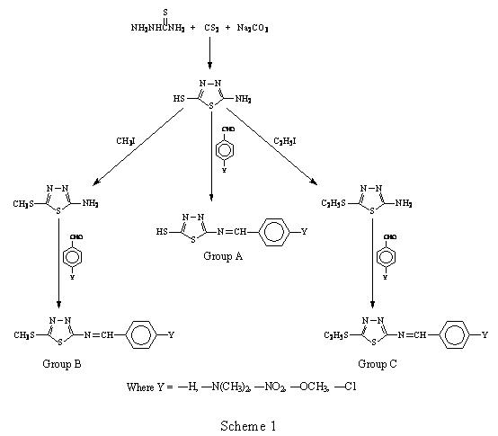

All synthesized compounds were characterized by elemental analysis, IR and 1HNMR spectral data, Tables 1, 2 and 3.
Elemental analysis data, Table 1 of some of these compounds were consistent with the expected composition of the structural formula of these compounds.
IR spectra of the synthesized compounds, show characteristics absorption bands, Table 2 at 1580-1680 cm-1 which are assignable to $ν$_{C=N} stretching for all compounds of the three groups. A weak absorption bands at 1290-1325 cm⁻¹ which are attributed to $ν$_{C=S} for group A compounds. This confirm that thiol group SH is in the thione form. For group B compounds a medium bending absorption band occurs at 1415-1440 cm⁻¹ due to δ_{CH3S} bending. While, the characteristic medium peak of group C compounds appear at 1420-1440 cm⁻¹ could be attributed to ν_{CH2S}. Figures 1-3 illustrated IR spectra of compounds A2, B1 and C1 respectively as a representative examples of the synthesized compounds.
The chemical shifts in 1HNMR spectra of some of these compounds are listed in Table3 and illustrated in Figures 4, 5 and 6 for compounds A3, B1 and C2 respectively.. These chemical shifts indicate the presence of aromatic protons around $δ$=7.21-8.39 as multiplets. The singlet at $δ$= 9.06-10.14 are attributable to the proton of azomethine group. The characteristics peaks for other protons inside of chemical structural formula of these compounds are also presented in Table 3.
The biological activity of these compounds will be the object of the next publication which is in progress.

Table 1. Characteristic IR absorption Bands of the synthesised compounds

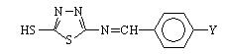
Compound | Y | $$ν_{C−H(\text{arom})}$$ | $$ν_{C−H(\text{aliph})}$$ | $$ν_{C=S}$$ | $$ν_{C=N}$$
A1 | -H | 3100-3000 | 3000-3170 | 1310 | 1675
A2 | -N(CH₃)₂ | 3060-3120 | 3000-3080 | 1310 | 1540
A3 | -NO₂ | 3015-3120 | 3000-3070 | 1325 | 1690
A4 | -OCH₃ | 3000-3080 | 3000-3170 | 1290 | 1645
A5 | -Cl | 3020-3100 | 3000-3280 | 1325 | 168
Compound | Y | $$ν_{C−H(\text{arom})}$$ | $$ν_{C−H(\text{aliph})}$$ | $$ν_{{\text{CH}}_{3}−S−}$$ | $$ν_{C=N}$$
B1 | -H | 3060-3120 | 2916-2960 | 1415 | 1630
B2 | -N(CH₃)₂ | 3020-3140 | 2810-2910 | 1440 | 1670
B3 | -NO₂ | 3020-3100 | 2900-2960 | 1430 | 1660
B4 | -OCH₃ | 3020-3100 | 2920-3000 | 1415 | 1630
B5 | -Cl | 3040-3100 | 2920-2980 | 1415 | 1675
Compound | Y | $$ν_{C−H(\text{arom})}$$ | $$ν_{C−H(\text{aliph})}$$ | $$ν_{−{\text{CH}}_{2}−S−}$$ | $$ν_{C=N}$$
C1 | -H | 3040-3100 | 2910-3000 | 1420 | 1630
C2 | -N(CH₃)₂ | 3060-3140 | 2900-2960 | 1440 | 1660
C3 | -NO₂ | 3060-3100 | 2910-2980 | 1440 | 1670
C4 | -OCH₃ | 3020-3130 | 2900-2980 | 1430 | 1630
C5 | -Cl | 3020-3100 | 2900-3000 | 1420 | 1680

Table 2. Elemental analysis data for the synthesized compounds
Compounds | Theoretical |  |  | Experimental
Compounds | C% | H% | N% | C% | H% | N%
A1 | 48.86 | 3.16 | 19.00 | 48.69 | 3.30 | 18.85
A2 | 50.00 | 4.54 | 21.21 | 49.73 | 4.59 | 21.51
A4 | 47.80 | 3.58 | 16.73 | 47.42 | 3.61 | 17.02
A5 | 42.25 | 2.34 | 16.43 | 24.41 | 2.48 | 16.25
B1 | 51.10 | 3.28 | 17.87 | 51.34 | 3.51 | 17.91
B2 | 51.79 | 5.03 | 20.14 | 51.73 | 5.16 | 20.55
B3 | 42.85 | 2.85 | 20.00 | 43.03 | 2.92 | 19.76
C2 | 53.42 | 5.48 | 19.17 | 53.17 | 5.55 | 19.42
C3 | 44.89 | 3.40 | 19.04 | 45.07 | 3.51 | 19.42
C5 | 46.54 | 3.52 | 14.81 | 46.68 | 3.48 | 14.53

Table 3. Nuclear magnetic resonance data for some of the synthesised compounds
Compounds | Coupling Constant | Chemical Shift/ppm
A3 |  | $δ$= 7.07 ( -SH, 1H, s )  $δ$= 13.55 ( -NH, 1H, s )  $δ$= 10.14 ( N=CH, 1H, s )  $δ$=8.31 ( arom., 4H, m )
B1 |  | $δ$=2.57 ( -CH₃, 3H, s )  $δ$= 8.7 ( N=CH, 1H, s )  $δ$= 7.21 ( arom., 5H, s )
B3 |  | $δ$= 2.78 (-CH₃, 3H, s )  $δ$= 9.06 ( N=CH, 1H, s)  $δ$= 8.31 ( arom., 4H, q)
C2 | J= 7.32  J=7.32  J=8.85 | $δ$= 1.35 ( C-CH₃, 3H, t)  $δ$= 3.15 ( -S-CH₂, 2H, q)  $δ$= 8.57 ( N=CH, 1H, s )  $δ$= 3.01 ( N-(CH₃)₂, 6H, s)  $δ$= 7.73 ( arom., H, 4H, dd)
C3 | J=6.5  J=6.5  J=7.0 | $δ$= 2.45 ( C-CH₃, 3H, t )  $δ$= 4.14 ( S-CH₂-, 2H, q)  $δ$= 10.15 ( N=CH, 1H, s )  $δ$= 8.39 ( arom., H, 4H, dd)
s(singlet), d(doublet), m(multiplet), q(quartate)

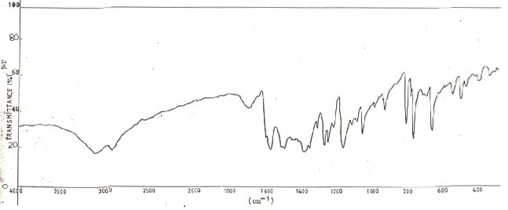
Figure 1. IR spectrum of compound A2
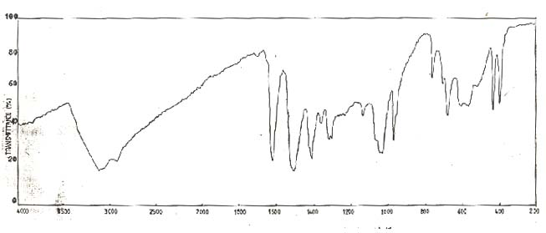
Figure 2. IR spectrum of compound B1

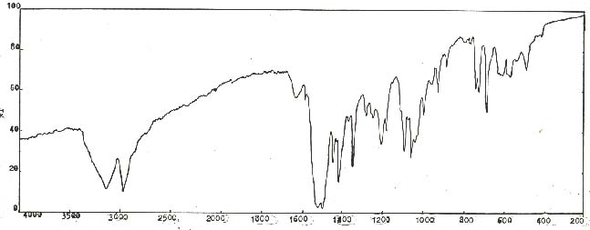
Figure 3. IR spectrum of compound C1
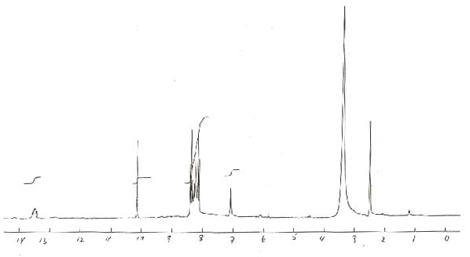
Figure 4. ¹HNMR spectrum of compound A3

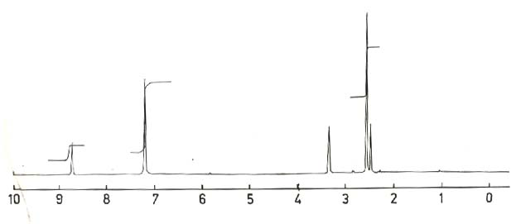

Figure 5. ¹HNMR spectrum of compound B1

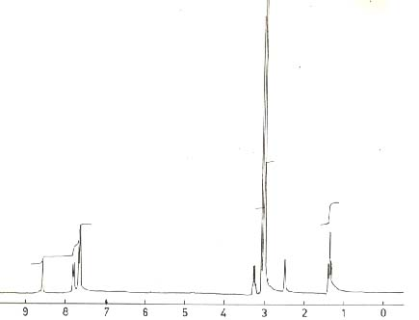

Figure 6. ¹HNMR spectrum of compound C1

References
- R. C. Elderfield, Heterocyclic Compounds, Vol. 7, Wiley, New York (1966).
- A. Hetzheim and K. Mockel, Advances in Heterocyclic Chemistry, A. R. Katrizky and A. J. Boulton (Editors), Vol. 7, Academic Press, New York(1966).
- F. Bentiss and M. Traisnel, Corrosion Sci., 2000, 42(1), 146.
- 4. L. Nuesslein, E. A. Pieroch and K. Roeder, US Patent, 4,061,645(1978).
- S. S. Tiwari, A. T. Sengupta and J. Kumar, Indian J. Pharm., 1970, 91, 32. K. Gupta and K. Hasela, J. Indian Chem. Soc., 1980, LVIII, 691.
- S. Giri, H. Singh and L. D. S. Yadvo, Agr. Biol. Chem., 1976, 40, 17.
- V. J. Ram and H. N. Fanday, J. Indian Chem. Soc., 1974, 51, 634.
- I. Angelini and F. Sparaco, British Patent, 1,601,801(1969).
- H. Najer, R. Cindicelli and J. Menin, Bull. Soc. Chim., France, 1966, 153.
- S. K. Chandhary and S. S. Parmar, J. Pharm. Sci., 1978, 67, 1507.
- J. B. Onel, H. Rosen, P.B. Rusell, A. C. Adam and A. Blumenthal, J. Med. Phrm. Chem., 1962, 5, 617.
- S. M. Alwan, S. K. Abdulrhman, H. A. Twaiji, S. S. Thily and F. Abdulhafidh, Under publication.
- I. S. Al-Shaibany, S. M. Alwan and S.Abdulrahman, Mu,tah J. for Research and Studies, 1994, 9(2), 139.
- S. Somasekhara, V. S. Digha, N. K. Kumar, D, H. Desai, H. J. Mehta and A. C. Padhya, Indian J. Pharm., 1974, 36, 115.
- B. Dash, M. Patra and P. K. Mahapatra, J. Indian Chem. Soc., 1983, 60, 772.
- S. D. Barton and W. D. Ollis, Comprehensive Organic Chemistry, P. G. Sames (Editor), City University Press, London(1979).
- V. Petrow, O. Stephenson and A. J. Thomas, J. Chem. Soc., 1958, 1508.

