Detection of IVS 1-110 and IVS 1-5 Mutations in β-Thalassemia Major Patients in Babylon Province

Ahmed J. Mohammed¹ Mahdi Mohamed Ridha¹ Lamees M. Al-Janabi²
¹College of Pharmacy, Kufa University
²College of Medicine, Dhiqar University



Received 7 January 2015 Accepted 12 January 2015
Abstract
One hundred blood samples of beta thalassemia major patients were collected in Thalassemia center of Babylon hospital for Maternity and children in Hilla city. In addition, blood samples were collected from 40 apparently healthy subjects as a control group (without Hemoglobinopathy disorders). All samples of blood were subjected to isolation of DNA and molecular characterization of two β-thalassemia mutations {IVS 1-110 (G-A) and IVS 1-5(G-C)} using a PCR-ARMS technique.
The result revealed that IVS1- 110 mutation was the most common in the patient's samples as (21%) whereas IVS1-5 mutation was present with a relatively less incidence as (10%). These point mutations are recorded for 1st time in Babylon governorate.
Keywords: thalassemia, mutation, globin

الخلاصة
تم جمع 100عينة دم لمرضى الثلاسيميا– بيتا كبرى من مستشفى بابل للولادة والأطفال في الحلة ومن 40 شخصا من الأصحاء ظاهريا وغير مصابين بإمراض الدم الوراثية كمجموعة سيطرة. استخلص الحامض النووي (DNA) , واجري التشخيص الجزيئي لنوعين من الطفرات الوراثية المسببة للثلاسيميا – بيتا وهي: (IVS1-110 and IVS1-5) باستعمال تقنية الـ PCR-ARMS. وجد أن الطفرة (IVS1-110) هي الأكثر شيوعا بين المصابين للبيتا ثلاسيميا بنسبة 21%. كما أن الطفرة ( IVS1-5) موجودة ولكن بنسبه اقل من الطفرة الأولى ، حوالي 10%. يذكر ان هذه الطفرات يتم تشخيصها لاول مرة في محافظة بابل .
ـــــــــــــــــــــــــــــــــــــــــــــــــــــــــــــــــــــــــــــــــــــــــــــــــــــــــــــــــــــــــــــــــــــــــــــــــــــــــــــــــــــــــــــــــــــــــــــــــــــــــــــــــــــــــــ

Introduction
Thalassemia is a genetic disease that occur as a result of specific hemoglobin (Hb) genes mutations, affecting the Hb makeup in the RBCs, which leads to some pathophysiological abnormalities [1]. This inherited disorder is manifested by partial or absolute production of one or more beta (β)- or alpha (α)-globin chain [2,3]. Beta-thalassemia are classified clinically into three types which are minor, intermedia, and major. Beta thalassemia major arises due to two genes defect that result in absence or a severe reduction in beta-globin chainproduction. Frequently, the disease was predominant in the malarial, subtropical and tropical regions of Mediterranean countries, Transcaucasus, Middle East, Southeast Asia, the Indian Subcontinent and Central Asia [4].Carriers of beta-thalassemia comprise 1.5% of the worldwide populations, with about 60,000 infants being born every year with a serious defect [1].
Beta-thalassemia is a common inherited disorder which results from mutations in one or more of the beta-globin gene loci that lead to decrease β-globin synthesis [5]. Nowdays, rather than two hundred different mutations have been diagnosed affecting the diverse β-globin gene expression levels and lead tobeta-thalassemia. These mutations are not distributed uniformly, but have a racial origin and geographic specificity, as each is distinguished by the existence of some common mutations and variable numbers of rare ones [6].
Mutations such as substitutions of single nucleotide and/or frame shifts of the deletion / insertion type led to interference with the β-globin gene transcription, splicing procedures and translation of mRNA of β-globin gene, resulting in either absolute or partial reduction of β -globin chain synthesis [7]. Most of these mutations activate aberrant cryptic 5’ donor or 3’ acceptor splice sites without completely abolishing normal splicing. These mutations lead to the production of variable amounts of normal transcripts. Some mutations allow a significant level of normal splicing (such as IVSI-6), leading to thalassemia intermedia, while others reduce normal splicing to low levels (such as IVSI-110) or very low levels (such as IVSI-5), causing transfusion-dependent disease [8].
The aim of this study is to detect IVSI-110 and IVSI-5in thalassemia major patients in Hilla

Materials and Methods
This study was conducted during the period starting from December 2013 to August 2014. One hundred β-thalassemia major patients were included in this study; the patients were diagnosed and registered as thalassemia major in thalassemia center in Babylon hospital for maternity and children. A case sheet for each patient, including: name, sex, date of birth, age of presentation, consanguinity of parents had been prepared.
Three ml of venous blood was withdrawn from each patient prior to transfusion. The isolation of genomic DNA from the fresh whole blood collected in EDTA anticoagulant tubes for molecular investigation was done using Geneaid genomic DNA extraction kit.
Methods
"Amplification Refractory Mutation System"(ARMS-PCR) permits the detection of point mutations directly by the absence or presence of amplification using primers of specific allele. For the characterization of specific point mutation a pair of allele-specific primers one of which has its 3′ terminal nucleotide complementary to the point mutation (Mt ARMS primer) and other to the normal DNA sequence (N ARMS primer) was used.
According to the distribution of common of β-thalassemia mutations in the surrounding countries [10-13], two mutations are selected for molecular characterization in Babylon governorate.
Primers Selection
Sets of primers which are chosen for mutations ARMS analysis are listed in table 1 [14,15].
For all reactions of ARMS-PCR:
- Internal control primers:
Primer A (Forward): "5⁻-CAA TGT ATC ATG CCT CTT TGC ACC -3⁻"
Primer B (Reverse): "5⁻-GAG TCA AGG CTG AGA GAT GCA GGA-3^{-"}
" The fragment size of internal control primers product was 861 bp".
Common primer C: "5⁻-ACC TCA CCC TGT GGA GCC AC3'"

Table (1): Primers sequences to detect β-globin gene mutations. Mutant and Normal Primer

Mutation |  | Sequence (5'-3') | Product bp
IVSI-5 (G – C ) | Mutant | ”5-CTC CTT AAA CCT GTC TTG TAA CCT TGT TAG-3" | 285
IVSI-5 (G – C ) | Normal | "5-CTC CTT AAA CCT GTC TTG TAA CCT TGT TAC-3" | 285
IVS1-110 (G – A) | Mutant | "5-ACC AGC AGC CTA AGG GTG GGA AAA TAG AGT-3" | 419
IVS1-110 (G – A) | Normal | "5-ACC AGC AGC CTA AGG GTG GGA AAA TAC ACC-3" | 419

PCR reaction mixture contained 7μl of genomic DNA, 15 μl 2X Taq PLUS PCR Pre-Mix, 1 μl common primer C, 1 μl of either mutant(M) or normal(N) primer, 1 μl of each Internal Control Primer A and B, and 4 Nuclease free water(total volume 30μl). Mixture constituents of all reaction were purchased from SolGent Corporation. All reaction tubes were then subjected to thermal cycles on a DNA thermal cycler (Biometra, Germany).
For detection ofIVS1-110 and IVS1-5mutations, the program of ARMS-PCR was("25 cycles: preheating at 94 °C for 2 min, denaturing at 94 °C for 1 min, annealing temperatures65°C for 1 min, and extension at 72 °C for 1.5 min and Final extension72°C for 3 min").
The ladder marker and the ARMS-PCR products are resolved by electrophoresis. "7μl of the product were loaded on 2 % agarose gel (2g agarose/100 ml), 1X TBE buffer with Ethidium bromide solution (0.5 μg/ml) and run at 70 volt" for two hours. Subsequently , bands are visualized on UV transiluminator and then photographed by using photo documentation system [16].
An internal control band (861 bp) was also amplified in all reactions indicating successful PCR. The PCR products were finally analyzed by electrophoresis.

Result
The pattern of results of the studied types of β-thalassemia major mutations screening for 100 β-thalassemia major samples are presented in the following figures: Figure (1) shows an electrophoretic example of bands when IVS1-110 mutation is present. Whereas Figure (2) shows an electrophoretic example of bands when IVS1-5 mutation is present .

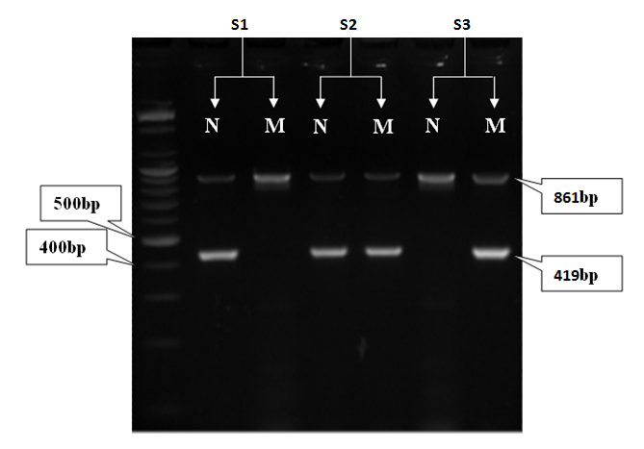
Figure (1): ARMS-PCR products of IVS 1-110 β-thalassaemia mutation on 2% agarose gel at 70 voltages for two hours. S1: sample 1 Normal genotype, S2: sample 2 Heterozygous genotype, 3 sample 3 Homozygous genotype. Marker: ladder marker DNA 100bp.N: Normal; M: Mutant.
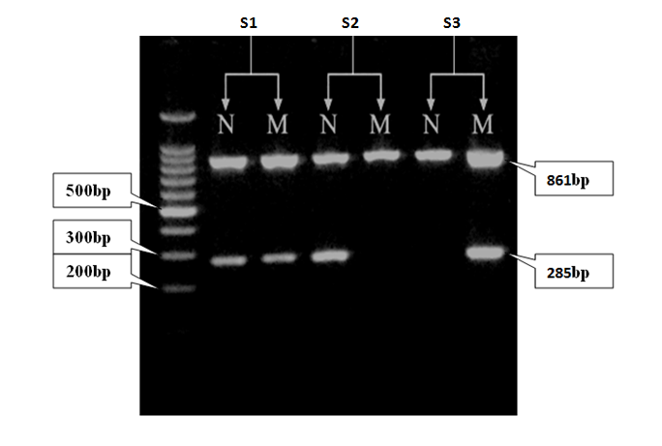
Figure (2): ARMS-PCR products of IVS-І-5 β-thalassaemia mutation on 2% agarose gel at 70 voltages for two hours. S1: sample 1 Heterozygous genotype, S2: sample 2 Normal genotype, S3: sample 3 Homozygous genotype. Marker: ladder marker DNA 100bp. N: Normal; M: Mutant.

The result of mutations identification for all β-thalassemia samples were presented in table (2). The results revealed the most common mutation was IVS1-110 as 21% followed by IVS1-5 mutation as 10%.
There were β-thalassemia samples which did not show any of the four Asian -Indian and Mediterranean mutations were studied as 69% while one sample showed both IVS1-110 and IVS1-5 mutations. Furthermore nobody of control group show any of the investigated mutations.

Table (2): No. of different mutations identified in 100 samples of β-thalassemia patients.
Mutation | Total no. | %
IVS1-110 | 21 | 21%
IVS1-5 | 10 | 10%
IVS1-110& IVS1-5 | 1 | 1 %
Undetermined | 69 | 69%

Discussion
A number of β-thalassemia samples did not showany of the four examined mutations.This observation could be due to the presence of other beta-thalassemia mutations not screened for in this methodology. In this case, the best way to detect if those patients have another mutations or not was to sequence their beta-globin gene.
β-thalassemia disorder has high heterogeneity in molecular level. Up to now, rather than 200 different β globin gene mutations have been listed [17], and each race and population have their own mutations [18]. Among the previous studies, only few references dealt adequately with the Iraqi governorates. This study was designated to provide a more detailed analysis especially in Babylon governorate.
The mutation IVS 1.110 (G >A) (create new splice site), which was the first most common mutation in this study, a finding similar to that obtained in other Iraqi study. Al-Zaaget al.,[19] found the mutation types were identified in 12 chromosomes in the samples of 40 Iraqi β-thalssemia patients are IVS1-110 and IVS1-1.
The mutation IVS 1.110 was the 2nd most common mutation in southern Iran [20] and the predominant mutation in Saudi Arabia, Syria, Jordan and in Turkey [21,22,23, 24]. It is the very common cause of beta-thalassemia in Mediterranean countries, especially eastern Mediterranean region, but reaches lower frequencies in countries around the Arabian Gulf.
While IVS 1.5 (G - C) (consensus change mutation) occur in Mediterranean region. It is the 2nd most common mutation in this study with frequency of 10%. The frequency of this mutation in this study agreed with Al-Assadi [25] study which has been showed that the IVS1-5 frequency has been 12.5% in thalassemia patients in Iraq. It is the commonest mutation in Oman (62%) and Emirate (55%) and is quite frequent in neighboring Saudi Arabia and Kuwait.

References
1. Higgs DR, Engel JD, Stamatoyannopoulos G: Thalassaemia. Lancet 2012, 379:373–383.
2. Viprakasit V, Lee-Lee C, Chong QT, Lin KH, Khuhapinant A: Iron chelation therapy in the management of thalassemia: the Asian perspectives. Int J Hematol 2009, 90:435–445.
3. Akhtar MS, Qaw F, Borgio JF, Albuali W, Suliman A, Nasserullah Z, Al-Jarrash S, Al-Ali A: Spectrum of alpha-thalassemia mutations in transfusion dependent beta-thalassemia patients from the Eastern Province of Saudi Arabia. Hemoglobin 2013, 37:65–73.
4. Weatherall DJ (2006). The Thalassemias: Disorders of Globine Synthesis. Hematology.7th ed. New York: McGrow Hill. Pp: 633-66.
5. MokS, Imwong, M and Mackinnon, M. J. (2011). “Artemisinin resistance in Plasmodium falciparum is associated with an altered temporal pattern of transcription.” BMC Genomics.V12 article 391.
6. Cao A and Galanello R, (2010). Beta-thalassemia. Genet Med.
12(2):61–76.
7. Lahiry, P.; Al-Attar, S.A. and Hegele, R.A. (2008). Understanding Beta-Thalassemia with Focus on the Indian Subcontinent and the Middle East. The open hematology journal. 2:5-13.
8. Jim Vadolas1*, Mikhail Nefedov1, Hady Wardan1 et;al (2006). Humanized β-Thalassemia Mouse Model Containing the Common IVSI-110 Splicing Mutation.J. Biol. Chem. Published, 10.1074/jbc. M512931200.
9.Cappellini MD, Cohen A, Piga A, Bejaoui M, et al: A phase 3 study of deferasirox (ICL670), a once-daily oral iron chelator, in patients with beta-thalassemia. Blood 2006, 107:3455–3462.
10Rahimi, Z.,Muniz, A and Parsian, A. (2010). Detection of responsible mutations for beta thalassemia in the Kermanshah Province of Iran using PCR-based techniques. MolBiol Rep. 37:149–154.
11. Roudknar MH, Najmabadi H, Derakhshandeh P et al. (2003). Detection of rare and unknown mutations in β- thalassemia traits in Iran. Iranian J Pub Health. V.32 (1):11-14.
12. Bhardwaj U, Zhang, Y., Lorey F., et al (2005). Molecular genetics confirmatory testing from newborn screening samples for the common African-American, Asian Indian, Southeast Asian, and Chinase β- thalassemia mutations. American Journal of Hematology .78:249-255.
13. Chan OT, Westover K.D, Dietz L, et al (2010). Comprehensive and efficient HBB mutation analysis for detection of betahemoglobinopathies in a pan-ethnic population. Am. J. Clin. Pathol. 133 (5): 700-707.
14.Christopher A F., Kumari A., Chaudhary S., Hora S., Ali Z., Agrawal SC.(2013).Unique pattern of mutations in β-thalassemia patients in Western Uttar Pradesh.19(2): 207-212.
15. Saleh-Gohari N and Bazrafshani MR. (2010). Distribution of β-Globin Gene Mutations in Thalassemia Minor Population of Kerman Province, Iran. Iranian J Publ Health,Vol. 39(2):.69-76.
16. Talmaci R. Traeger J., Kanavakis E. et al (2004). Scanning of β-globin gene for identification of β- thalassemia mutation in Romanian population. J.Cell. Mol.Med., 2:232-240.
17. Huisman TH (2000). The beta and alpha thalassemia repository, Hemoglobin, 22 (2): 169 - 95.
18. Najmabadi, H.;Pourfathollah, AA.; Neishabury, M.; Sahebjam, F.; Krugluger, W. and Kanins, C. (2002). Rare and unexpected mutation among Iranian beta-thalassemia patients and prenatal samples discovered by reverse-hybridization and DNA sequencing. Haematologica. 87:1113-1114.
19.Al-Zagg, A.; Altalay, E.; Cirakoglu, B. and Bermak, E. (1993).The detection of molecular types of β-thalassemia among Iraqi patients using oligo probes and amplified DNA. Proc. Sec. Arab. Conference on biotechnology.Amman.
20. Merat A., Haghshenas M., Pour Z.M. Plonczynski MW., Harrel AN., Coleman MB. and Steinberg MH. -Beta-thalassemia in southwestern Iran. Hemoglobin (1993), 17(5):427-37.
21. El-Harith E.A. and Al-Shahri A. -Identification and clinical presentation of ß-thalassemia mutations in the eastern region of Saudi Arabia. J Med Genet (1999), 36:936-937.
22.Kyriacou K., Al Quobaili F., Pavlou E., Christopoulus G., Ioannou P., and Kleanthous M. – Molecular characterization of beta-thalassemia in Syria. Hemoglobin (2000), 24(1):1-13.
23. Sadiq M.F., Eigel A., and Horst J. -Spectrum of beta-thalassemia in Jordan: identification of two novel mutations. Am. J. Hematol. (2001), 68(1):16-22.
24. Basak A.N. -The molecular pathology of beta-thalassemia in Turkey: The Bogazici University experience. Hemoglobin (2007), 31: pp 233-41.
25. Al-Assadi, Zuhair (2007). Molecular detection of some mutations associated with β-thalassemia in Iraq. Ph.D thesis. Institute of Genetic engineering & Biotechnology. University of Baghdad. Iraq.

