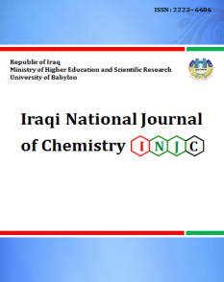

**Iraqi National Journal of Chemistry**

**Journal homepage: http://iqnjc.com/Default.aspx**

**Synthesis and Identification of some heterocyclic derivatives from carboxylic acid**

**Shaimaa Adnan Behget**

**College of Education, University of Al-Qadisiya**

[shemaadnan@yahoo.com](mailto:shemaadnan@yahoo.com)

**Abstract**

This research involved heterocyclic compounds such as (β-lactam ,oxazepine Thiazolidine -4- one , imidazolidin -4-one) derivatives , where prepared frome oxaliodihydrazide(1) which was prepared previously from oxalic acid.

(1) is reaction with 4-amino acetophenone to get shiff base derivatives (2),which reaction with Vanillin to yeild shiff base (3) .

(3) reaction with (Chloroacetyl chloride, thioglycolic acid ,phthalic anhydride , malic anhydride , succinic anhydride , glycine , alanine,tyrosine , phenylalanine) to get as [β-lactam derivatives(4) , Thiazolidine -4- one derivatives (5) , oxazepine derivatives(6), (7) and(8), imidazolidin -4-one derivatives(9) ,(10),(11) and((12) ].

All this compounds characterized by means of FT- IR ,and some of the compoundes by means 1H-NMR,and 13C-NMR,C.H.N, and follow reaction by Rf - TLC and Measure ment melting point .

**Key words**:-heterocyclic, β-Lactam ,Thiazolidin , Imidazolidin , oxazepine .

**تحضير وتشخيص بعض المشتقات الحلقيه غير المتجانسة من حامض كاربوكسيلي**

**شيماء عدنان بهجت**

**قسم الكيمياء , كلية التربية , جامعة القادسية**

**الخلاصة**

تضمن البحث تحضير مركبات حلقية غير متجانسه كمشتقات( البيتا-لاكتام, اوكسازبين, ثايازولدين , اميدازولدين) اللذي يحضر من الاوكزاليك ثنائي هيدرايزايد (1) المحضر سابقا من حامض الاوكزالك.

المركب (1) يتفاعل مع 4-امينواسيتوفينون لنحصل على مشتق قواعد شف (2) الذي يتفاعل مع الفانلين لنحصل على مشتق قواعد شف (3).

(3) يتفاعل مع ( كلورواستايل كلورايد , حامض الثايوكلايكولك, فثالك انهيدرايد ,مالك انهيدرايد ,سكسنك انهيداريد , كلايسين , الانين,تايروسين وفنيل الانين) لنحصل على ( مشتق البيتا لاكتام(4) و مشتق الثايازولدين(5) و مشتقات الاوكسازبين(6),(7)و(8) , ومشتقات الاميدازولدين( 9) ,(10),(11) و(12) على التوالي .

(CHN)تم تشخيص هذه المركبات بطيف الاشعة تحت الحمراء وتحليل العناصر الدقيق والبعض منها بطيف الرنين النوي المغناطيسي للهيدروجين والكاربون-13 ومتابعة التفاعل بواسطه كروموتوغرافيا الطبقة الرقيقة وقياس درجة الانصهار .

**Introduction**

In the 1940s has been used β- lactam antibiotics to cure bacterial infections,

Several of the amide and lactam derivatives are also a chemical reaction such as cephalosporins.

Also noted several other biological activities like anti-cancer activity, and the activity of blood sugar, and antitubercular activity and anti-leishmaniasis activity in compounds containing β-lactam ring (1-3).

oxazepines belongs to the heterogeneous group of compounds, which are due

Biologically important molecules components such as nucleic acids, hormones and therapeutic drugs (4-6).

It seems that thiazolidine anion system to be interesting and attention because of the biological impacts of their own. It was reported as anti-inflammatory and analgesic, antitubercular, antimicrobial and antifungal, antiviral (private agents anti HIV, anti-cancer, antioxidant, anticonvulsants, agents antidiabetic (7-9).

Imidazolidin represent an exciting class of compounds of interest with regard biological activity. Via the manipulation of substitutes around the core imidazolidin, was the discovery of molecules with a variety of biological properties. One example is the compounds that show antibacterial activity (10-12).

**Experimental Apparatus**

(FTIR)Spectra(4000-400cm-1)in KBr disk were recorded by a SHIMADZU FTIR-8400S fourier. transform. melting point were measured using Stuart, UK. Elemntal Analysis 3764,carlo erba Europ .

1HNMR were recorded by fourier transformation bruker spectrometer ,operating at (400MHz) with (DMSO-ds) measurments were made at Department of chemistry ,kashan university .Iran ,

**1-Synthesis of Oxalic acid dihydrazide (1) (13)**

**a- Synthesis of diethyl oxalate**

Treating (0.22 mole,20 g) of oxalic acid with (20ml) absolute ethanol, (5ml) conc. Sulphuric acid and refluxed the mixture for 6 hours,yield the expected ester yield 62.27%

**b**-diethyl oxalate was synthesized by addition of hydrazine hydrate (0.32 mole, 10 ml) to (0.16mole, 23 ml) [1] in ( 25) ml of absolute ethanol then the mixture was refluxed for 2 hours. After cooling, the product was filtered off and recrystallized by using ethanol, m.p. 153-155 0C ,lit (14) 151-153,and yield(85%).

**2- Synthesis of N'1,N'2-bis(1-(4-aminophenyl)ethylidene)hydrazine hydride (2) (15)**

A mixture of ( 0.02mol) of p-aminoacetophenone and (0.01mol) (1) was refluxed for 2h in 20 mL of ethanol and Add drops of acetic acid .The reaction mixture was cooled and kept for 24 hs.The crystals found was filtered , dried and recrystallized from ethanol to give compound (2) .

**3- Synthesis of N'1,N'2-bis(1-(4-((4-hydroxy-3-methoxybenzylidene)amino)phenyl) ethylidene)oxalohydrazide (3) (15)**

A mixture of ( 0.02mol) of Vanillin and (0.01mol) (2) was refluxed for 2h in 20 mL of ethanol and Add drops of acetic acid .The reaction mixture was cooled and kept for 24 hs.The crystals found was filtered , dried and recrystallized from ethanol to give compound (3) .

**4**- **Synthesis of N1,N2-bis(3-chloro-2-(4-(3-chloro-2-(4-hydroxy-3-methoxyphenyl)-4-oxoazetidin-1-yl)phenyl)-2-methyl-4-oxoazetidin-1-yl)oxalamide (4) (16)**

A mixture of (3) ( 0.001mol ) and triethylamine ( 0.012mol ) was dissolved in 1,4 – Dioxan ( 25mL ) , to this well stirred cooled solution of chloro acetyl chloride (0.0048mol)was added drop wise at10oC.The reaction mixture was stirred for 6 hs. Half of the solvent separated and yield (4) recrystallized from chloroform

**5**- **Synthesis of N1,N2-bis(2-(4-(2-(4-hydroxy-3-methoxyphenyl)-4-oxothiazolidin-3-yl)phenyl)-2-methyl-4-oxothiazolidin-3-yl)oxalamide**)dissolved in 1,4 dioxane(20mL),anhydrous zinc chloride(0.7mg)was added and refluxed for 8 h. The reaction was then cooled and the resulting solid was washed with sodium bicarbonate solution and final compound (5), recrystallized from absolute ethanol.

**6- Synthesis of N1,N2-bis(3-(4-(3-(4-hydroxy-3-methoxyphenyl)-1,5-dioxobenzo [e] [1,3]oxazepin-4(1H,3H,5H)-yl)phenyl)-3-methyl-1,5-dioxobenzo[e][1,3]oxazepin-4 (1H,3H,5H)-yl)oxalamide (6)** (18)

In a 100 ml round bottom flask equipped with double surface condenser fitted with calcium chloride guard tube was placed a mixture of 0.01 mole of shiffbase(3) and 0.04mole (phthalicanhydride) in 20 ml of Ethanol absolute.The reaction mixture was refluxed in water bath at 78Cْ 3he, the solvent was then removed and the resulting solid was recrystallized from anhydrous THF

**7- Synthesis of N1,N2-bis(2-(4-(2-(4-hydroxy-3-methoxyphenyl)-4,7-dioxo-1,3-oxazepin -3(2H, 4H , 7H)-yl)phenyl)-2-methyl-4,7-dioxo-1,3-oxazepin-3(2H,4H,7H)-yl)oxalamide (7)** (18)

In a 100 ml round bottom flask equipped with double surface condenser fitted with calcium chloride guard tube was placed a mixture of 0.01 mole of shiffbase(3) and 0.04mole (maleic anhydride) in 20 ml of Ethanol absolute.The reaction mixture was refluxed in water bath at 78Cْ 3he, the solvent was then removed and the resulting solid was recrystallized from anhydrous THF

**8- Synthesis of N1,N2-bis(2-(4-(2-(4-hydroxy-3-methoxyphenyl)-4,7-dioxo-1,3-oxazepan-3-yl)phenyl)-2-methyl-4,7-dioxo-1,3-oxazepan-3-yl)oxalamide (8)** (18)

In a 100 ml round bottom flask equipped with double surface condenser fitted with calcium chloride guard tube was placed a mixture of 0.01 mole of shiffbase(3) and 0.04mole (succinic anhydride) in 20 ml of Ethanol absolute.The reaction mixture was refluxed in water bath at 78Cْ 3he, the solvent was then removed and the resulting solid was recrystallized from anhydrous THF

**9- Synthesis of N1,N2-bis(2-(4-(2-(4-hydroxy-3-methoxyphenyl)-5-oxoimidazolidin-1-yl)phenyl)-2-methyl-5-oxoimidazolidin-1-yl)oxalamide (9)**

A mixture of schiff bases(3) ( 0.001mol ) dissolved in THF ( 15mL ) and glycine (0.004mol)was dissolved in THF (15mL)and refluxed for 24 hs.The reaction was then cooled and the resulting final (9) , recrystallized from absolute ethanol .

**10- Synthesis N1,N2-bis(2-(4-(2-(4-hydroxy-3-methoxyphenyl)-4-methyl-5-oxoimidazolidin-1-yl)phenyl)-2,4-dimethyl-5-oxoimidazolidin-1-yl)oxalamide (10)**

A mixture of schiff bases(3) (0.001mol)dissolved in THF( 15mL) and alanine (0.004mol) was dissolved in THF (15mL)and refluxed for 24 hs.The reaction was then cooled and the resulting final (10) , recrystallized from absolute ethanol

**11- Synthesis of N1,N2-bis(2-(4-(2-(4-hydroxy-3-methoxyphenyl)-4-(4-hydroxybenzyl)-5-oxoimidazolidin-1-yl)phenyl)-4-(4-hydroxybenzyl)-2-methyl-5-oxoimidazolidin-1-yl)oxalamide (11)**

A mixture of schiff bases(3) (0.001mol)dissolved in THF( 15mL) and tyrosine (0.004mol) was dissolved in THF (15mL)and refluxed for 24 hs.The reaction was then cooled and the resulting final (11) , recrystallized from absolute ethanol

**12- Synthesis of N1,N2-bis(4-benzyl-2-(4-(4-benzyl-2-(4-hydroxy-3-methoxyphenyl)-5-oxoimidazolidin-1-yl)phenyl)-2-methyl-5-oxoimidazolidin-1-yl)oxalamide (12)**

A mixture of schiff bases(3) (0.001mol)dissolved in THF( 15mL) and Phenylalanine (0.004mol) was dissolved in THF (15mL)and refluxed for 24 hs.The reaction was then cooled and the resulting final (12) , recrystallized from absolute ethanol

Schem1





**Results and Discussion**

**compound N'1,N'2-bis(1-(4-aminophenyl)ethylidene)oxalohydrazide (2)**

The compound(2) was obtained as paly yellow solid yield 77% , M.P( 259-260)OC

The infrared spectrum data of compound (2) showed band at (3047) cm-1 for (Ar-H), (3355-3480) cm-1  (N-H)to (NH2), (1317) cm-1  (C-N),(1635) cm-1  (C=N) .

The1H-NMR(CDCl3) spectrum data of compound (2) show δ:7.4-8.6(m,8H,Ar-H) , 6.8(s,4H,NH ,NH2), 3.7(m,6H,CH3), 6.5(s,2H,NH ,NH),.

The13C-NMR(DMSO) spectrum data of compound (2) show δ:16.5 (C6) , 200.52 (C7) 130(C5) , 130.4-161.5(aromating ring carbone)

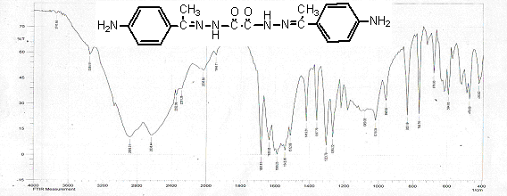

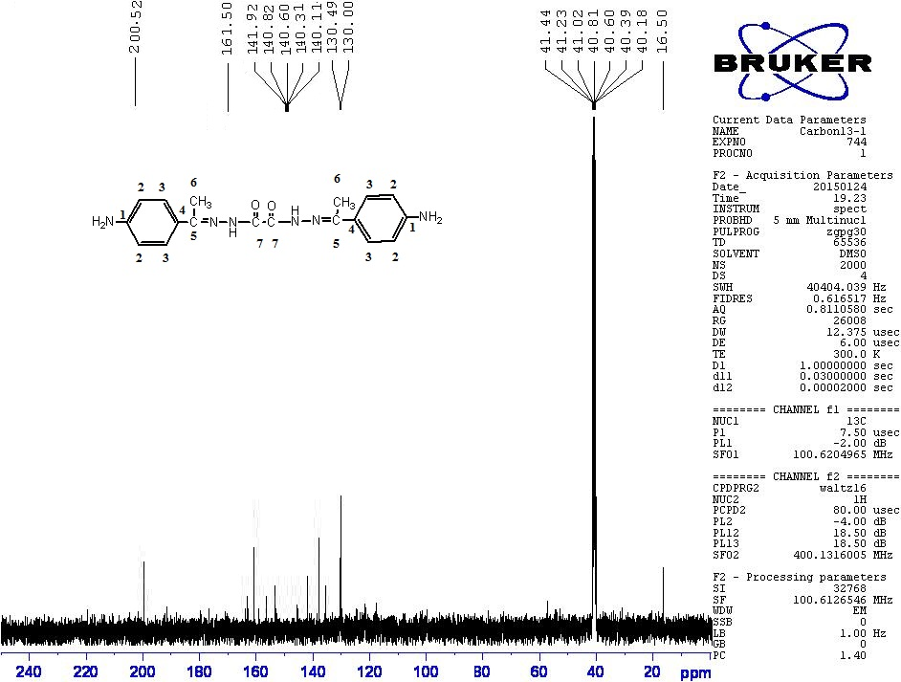

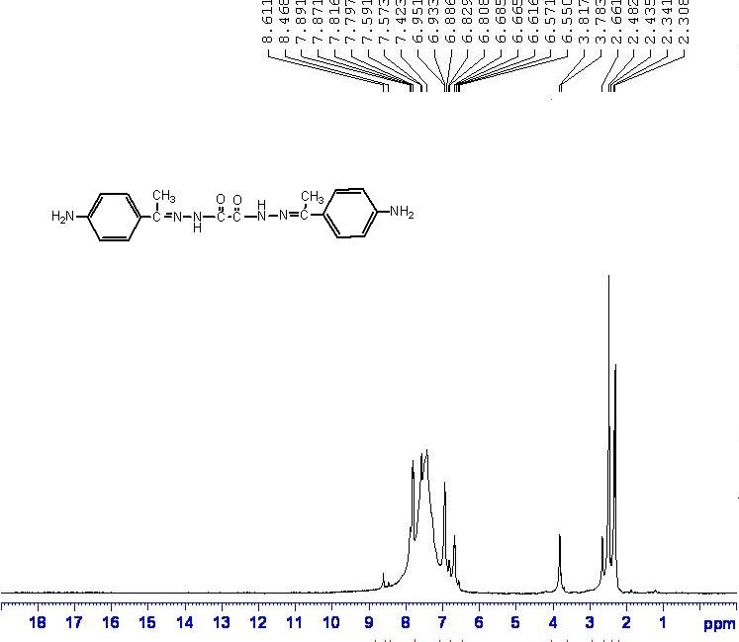

**compound N'1,N'2-bis(1-(4-((4-hydroxy-3-methoxybenzylidene)amino)phenyl) ethylidene) oxalohydrazide (3)**

This compound was obtained as orang solid yield 92%,Rf =0.42, M.P (197-199)OC.

The infrared spectrum data of compound (3) show absorption at (3047) cm-1 for (Ar-H),( 3181) cm-1  (N-H), (1319 )cm-1  (C-N),(1558) cm-1  (C=N),and show new band at (2990) for (C-H)CH3,(3250)for (OH)Phenol, (1680)for(C=O)imide.(17)

The1H-NMR(CDCl3) spectrum data of compound (3) show δ:7.0-8.4(m,14H,Ar-H) , 6.8(s,4H,NH ,NH), 3.7(m,6H,CH3), 4.7(m,6H,C-H ,OCH3), 5.2(m,2H,C-H ,CH).

The13C-NMR(DMSO) spectrum data of compound (3) show δ:15.61 (C1) , 173.0 (C17) 17.62(C16) , 49.98 (C8) , 114.83 (C15) , 127.37-159.78(aromating ring carbone)

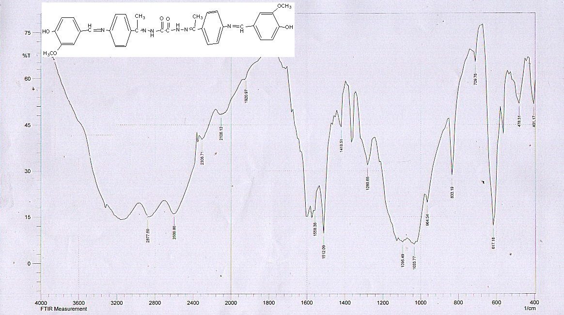

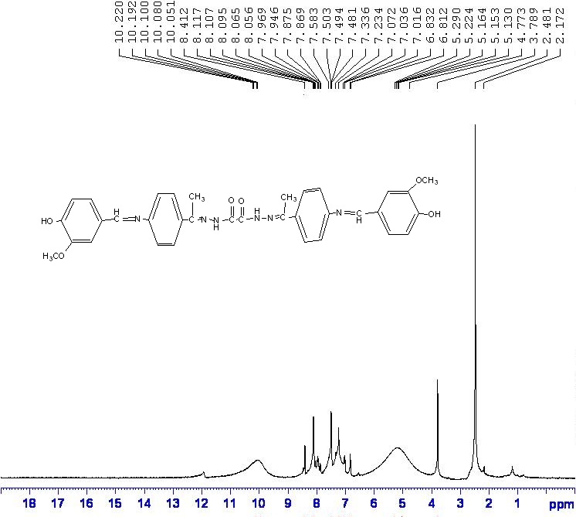

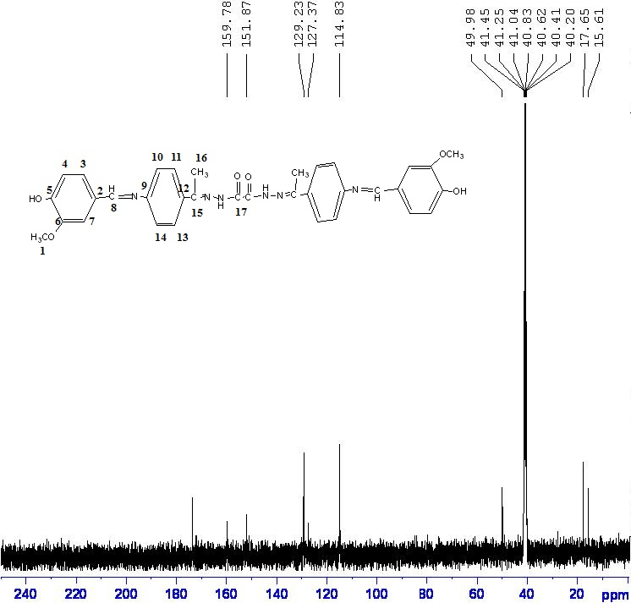

**compound (4)** **N1,N2-bis(3-chloro-2-(4-(3-chloro-2-(4-hydroxy-3-methoxyphenyl)-4-oxoazetidin-1-yl)phenyl)-2-methyl-4-oxoazetidin-1-yl)oxalamide** was obtained as brown seram yield 79% , Rf =0.35 , The infrared spectrum data of compound (4) show absorption at (3085) cm-1 for (Ar-H),( 3201) cm-1 (N-H),(1319 )cm-1  (C-N),(1589) cm-1  (C=N),and show new band at (2939) for (C-H)CH3,(3394)for (OH)Phenol, (1696)for(C=O)Beta-lactam,(848)for (C-Cl).(17)

The1H-NMR(CDCl3) spectrum data of compound (4) show δ:7.0-8.4(m,14H,Ar-H) , 6.8(s,4H,NH ,NH), 1.15(m,6H,CH3), 3.3(m,6H,C-H ,OCH3), 4.0(m,2H,C-H ,CH) 4.47(m,2H,Cl-CH ,CH), 10.1(s,1H,OH ).

The13C-NMR(DMSO) spectrum data of compound (4) show δ: 19.91 (C1) ,113.33 (C17) 9.93(C18) , 46.90 (C19) , 59.95 (C8) , 190.91 (C10,C20) 117.31-159.98(aromating ring carbone)

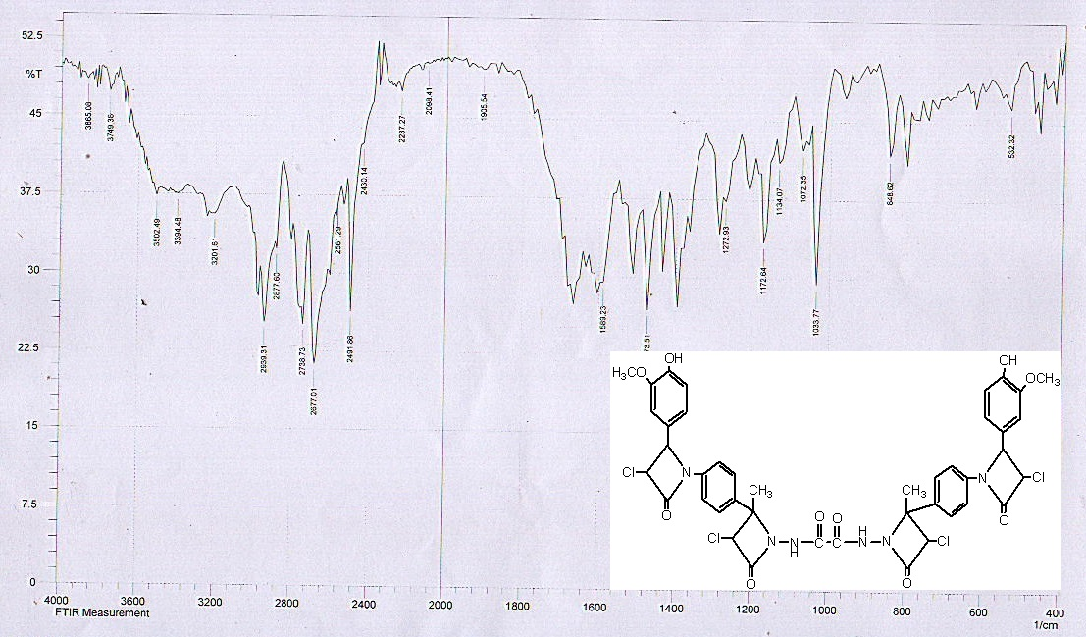

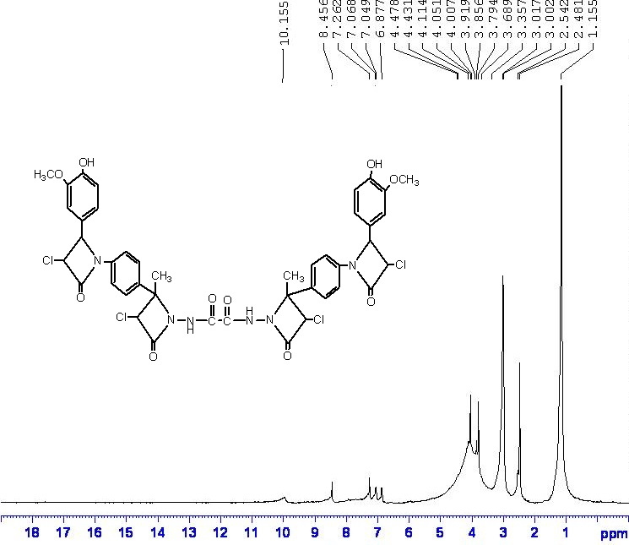

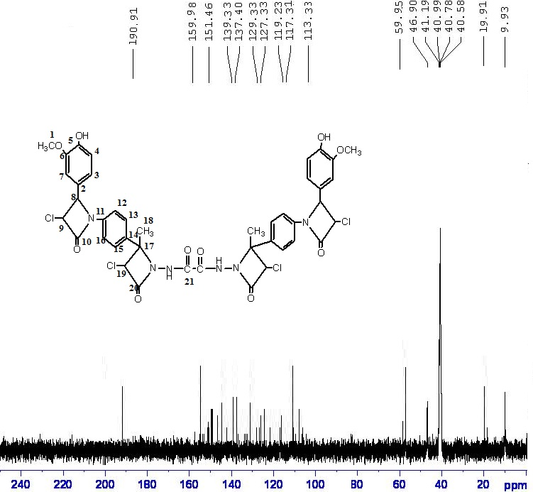

**compound(5)** **N1,N2-bis(2-(4-(2-(4-hydroxy-3-methoxyphenyl)-4-oxothiazolidin-3-yl)phenyl)-2-methyl-4-oxothiazolidin-3-yl)oxalamide**was obtained as white solid yield 86% , Rf =0.4 , M.P( 233-234)OC. The infrared spectrum data of compound (5) show absorption at (1120) cm-1 for (C-S),( 3178) cm-1 (N-H),,(3394)for (OH)Phenol, (1690)for(C=O) (17)

The1H-NMR(CDCl3) spectrum data of compound (5) show δ:6.5-7.66(m,14H,Ar-H) , 5.07(s,2H,NH ,NH), 3.3(m,6H,CH3), 3.8(m,6H,C-H ,OCH3), 4.3(m,2H,C-H ,CH) 4.8(m,2H, C-H ,CH), 10.3(s,2H,OH ).

The13C-NMR(DMSO) spectrum data of compound (5) show δ: 15.95 (C1) ,113.40 (C17) 9.99(C18) , 198.78 (C9,C19) ,78.90(C8) ,59.58 (C10,C20)117.85-159.98(aromating ring)

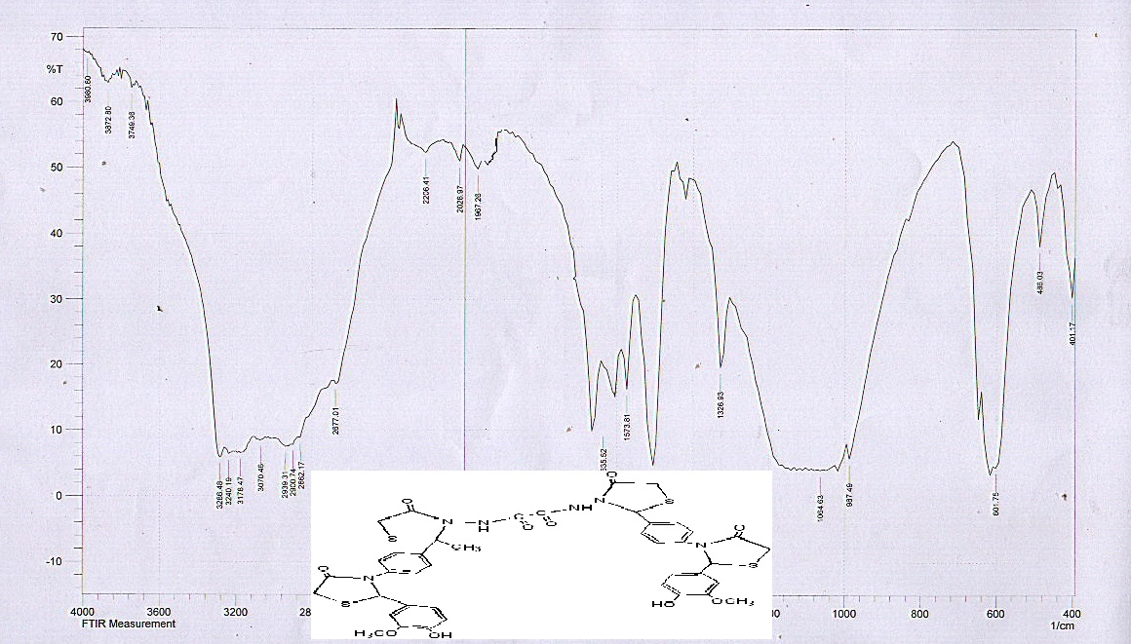

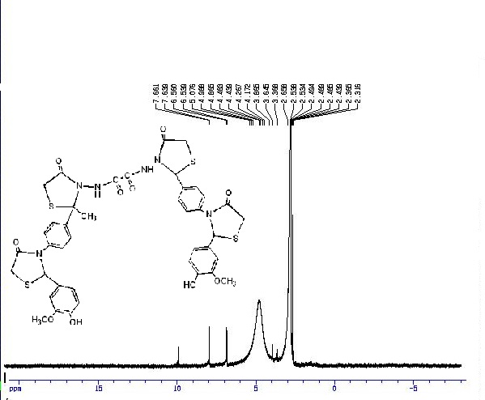

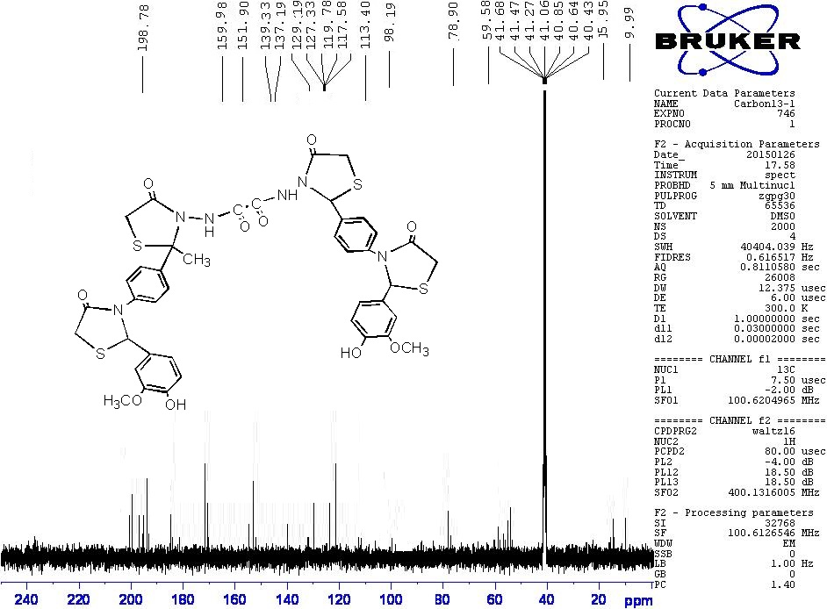

**compound(6) N1,N2-bis(3-(4-(3-(4-hydroxy-3-methoxyphenyl)-1,5-dioxobenzo [e] [1,3]oxazepin-4(1H,3H,5H)-yl)phenyl)-3-methyl-1,5-dioxobenzo[e][1,3]oxazepin-4(1H,3H,5H)-yl)oxalamide**was obtained as yellow solid yield 96% , Rf =0.38 , M.P ( 188-190)OC. The infrared spectrum data of compound(6)show absorption at(3240)cm-1 (N-H) ,,(3502)for (OH)Phenol , , (1600)for(C=C) , (1743)for(C=O) (17)

The1H-NMR(CDCl3) spectrum data of compound (6) show δ:7-8.4(m,38H,Ar-H) , 6.8(s,2H,NH ,NH), 3.7(m,6H,CH3), 3.8(m,6H,C-H ,OCH3), 6.3(m,2H,C-H ,CH) 6.5(m,2H, C-H ,CH), 10.2(s,2H,OH ).

The13C-NMR(DMSO) spectrum data of compound (6) show δ: 17.61 (C1) ,62.26 (C17) 14.15(C18) , 198.88 (C9,C19,C12,C21) ,49.48(C8) , 115.83-159.38(aromating ring)

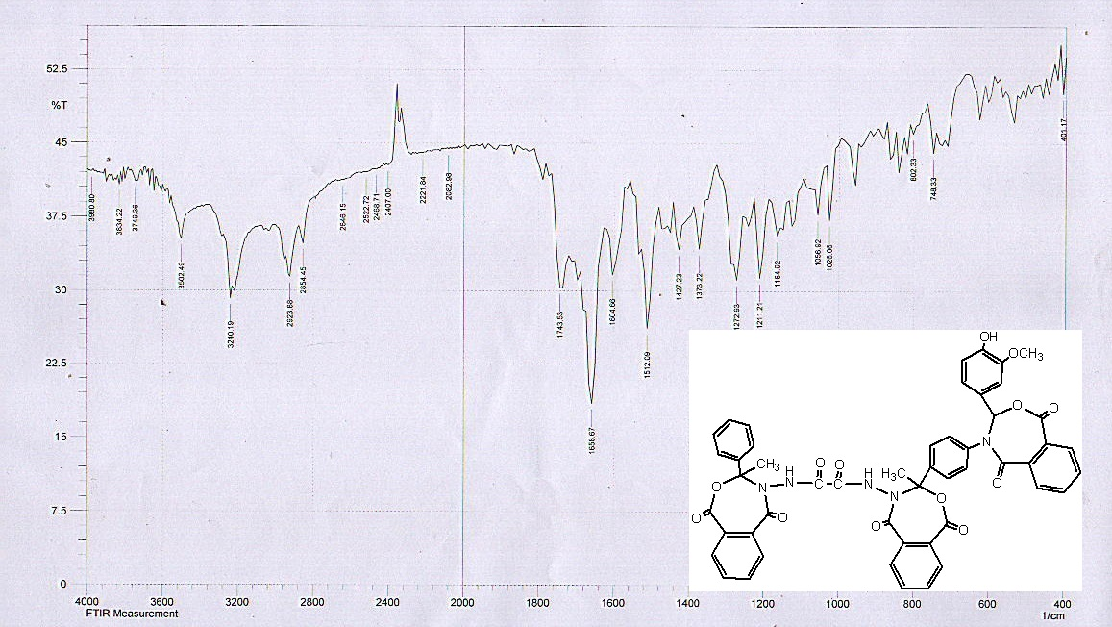

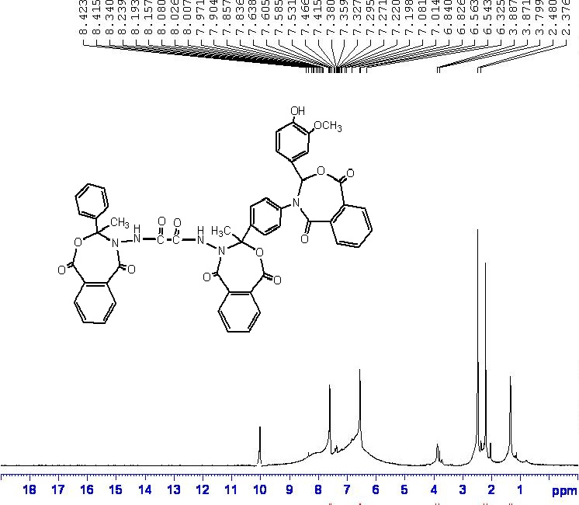

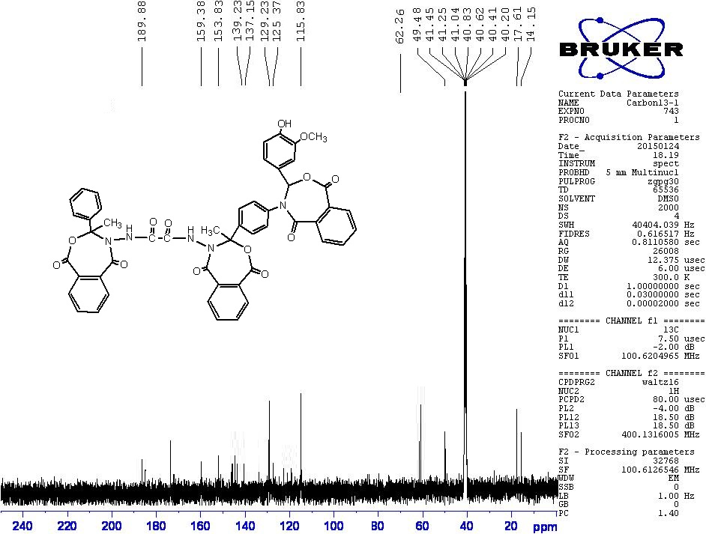

**compound (7)** **N1,N2-bis(2-(4-(2-(4-hydroxy-3-methoxyphenyl)-4,7-dioxo-1,3-oxazepin -3(2H, 4H , 7H)-yl)phenyl)-2-methyl-4,7-dioxo-1,3-oxazepin-3(2H,4H,7H)-yl)oxalamide** was obtained as yellow seram yield 81% , Rf =0.41.

The infrared spectrum data of compound(7)show absorption at (3047)cm-1 for(Ar-H) ,(3135) cm-1  (N-H),(1426)cm-1  (C-N), and show band at (2893-2962) for (C-H) CH3 (3502) cm-1  for (OH ) (1740) cm-1  (C=O) (18)

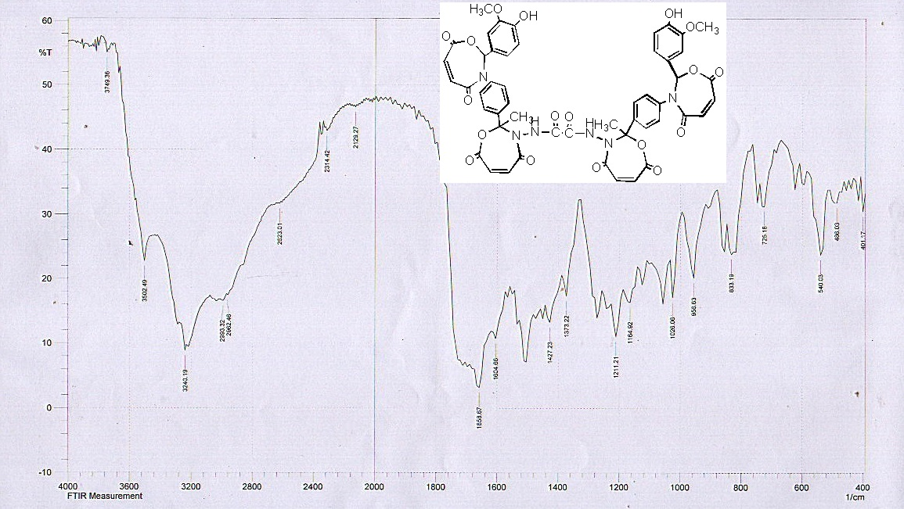

**compound (8)** **N1,N2-bis(2-(4-(2-(4-hydroxy-3-methoxyphenyl)-4,7-dioxo-1,3-oxazepan -3-yl)phenyl)-2-methyl-4,7-dioxo-1,3-oxazepan-3-yl)oxalamide**

was obtained as ywllow solid yield 74% , Rf =0.44 , M.P ( 237-238) OC.

The infrared spectrum data of compound(8)show absorption at (3040)cm-1 for(Ar-H) ,(3133) cm-1  (N-H),(1426)cm-1  (C-N), and show band at (2982) for (C-H) CH3 (3502) cm-1  for (OH ) (1730) cm-1  (C=O) (18

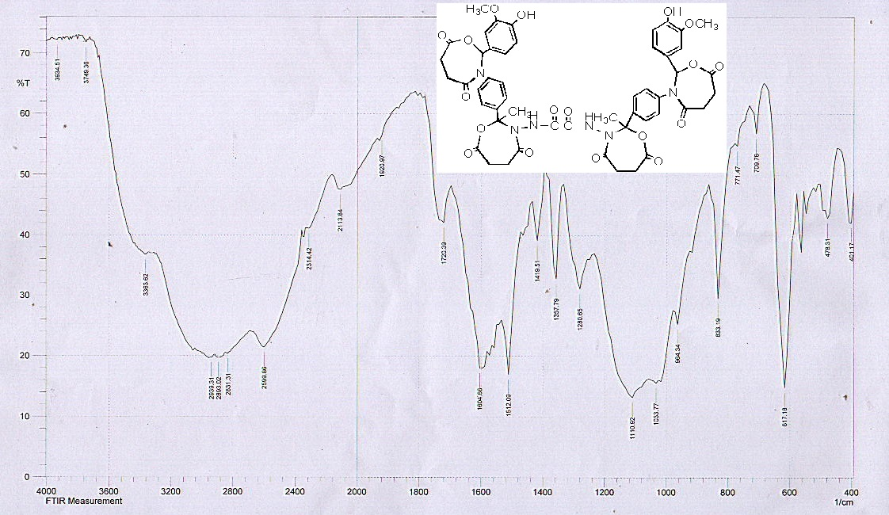

**compound (9)** **of N1,N2-bis(2-(4-(2-(4-hydroxy-3-methoxyphenyl)-5-oxo imidazolidin-1-yl)phenyl)-2-methyl-5-oxoimidazolidin-1-yl)oxalamide**was obtained as orang solid yield 77% , Rf =0.32, M.P( 349-250)OC. The infrared spectrum data of compound (9) show absorption at ( 3180) cm-1 (N-H),,(3383)for (OH)Phenol, (1700)for(C=O) (17)

The1H-NMR(CDCl3) spectrum data of compound (9) show δ:7-8.1(m,14H,Ar-H) , 6.8(s,4H,NH ,NH), 1.87(m,6H,CH3), 4.77(m,6H,C-H ,OCH3), 5.2(m,8H,C-H ,CH2) 10.77(s,2H,OH ).

The13C-NMR(DMSO) spectrum data of compound (9) show δ: 11.9 (C21) , 13.95 (C1) 59.99(C9,C18) , 77.94 (C8,C17) ,199.99(C10,C19)113.49-159.78(aromating ring)

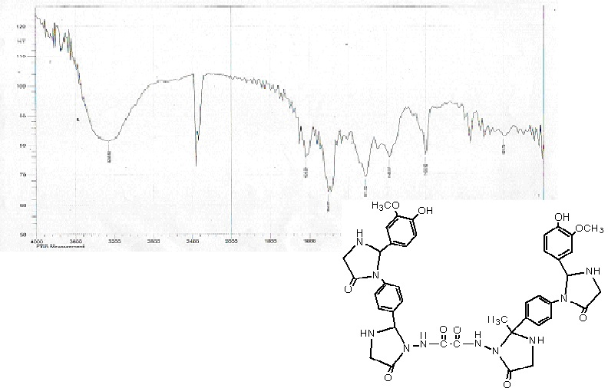

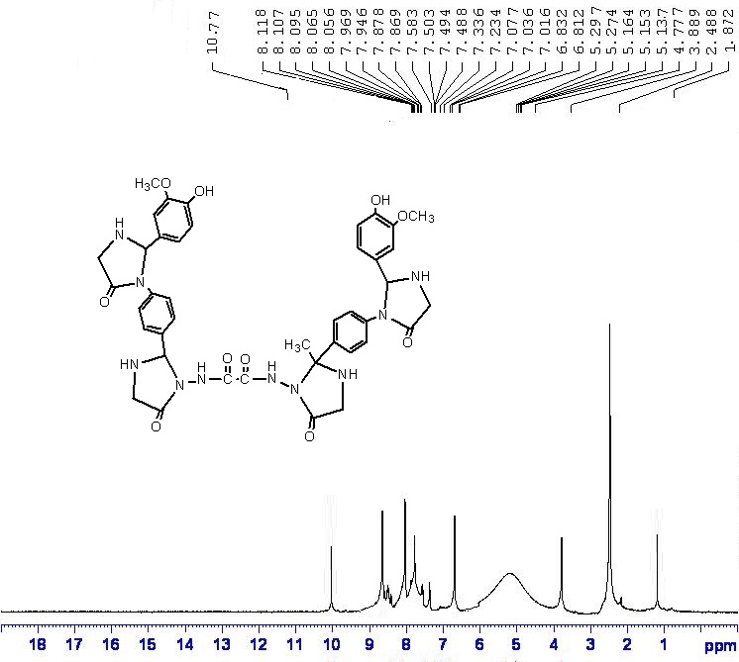

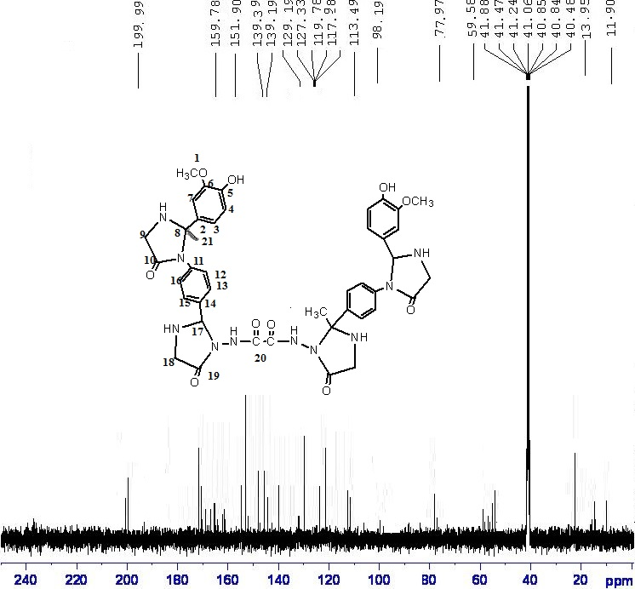

**compound(10)N1,N2-bis(2-(4-(2-(4-hydroxy-3-methoxyphenyl)-4-methyl-5-oxoimidazolidin-1-yl)phenyl)-2,4-dimethyl-5-oxoimidazolidin-1-yl)oxalamide**was was obtained as orang solid yield 86% , Rf =0.41 , M.P ( 215-217) OC.

The infrared spectrum data of compound(10)show absorption at (3044)cm-1 for(Ar-H) ,(3188) cm-1  (N-H),(1428)cm-1  (C-N), and show band at (2962) for (C-H) CH3 (3500) cm-1  for (OH ) (1710) cm-1  (C=O) (18)

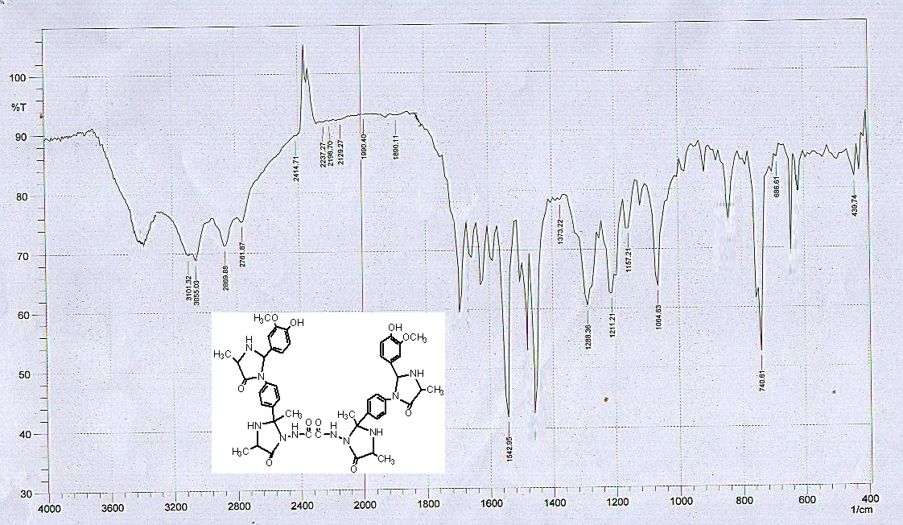

**compound (11**) **N1,N2-bis(2-(4-(2-(4-hydroxy-3-methoxyphenyl)-4-(4-hydroxybenzyl)-5-oxoimidazolidin-1-yl)phenyl)-4-(4-hydroxybenzyl)-2-methyl-5-oxoimidazolidin-1-yl)oxalamide**

was obtained as brown seram yield 80% , Rf =0. 3 .

The infrared spectrum data of compound(11)show absorption at (3054)cm-1 for(Ar-H) ,(3223) cm-1  (N-H),(1456)cm-1  (C-N), and show band at (2969) for (C-H) CH3 (3488) cm-1  for (OH ) (1718) cm-1  (C=O) (18)

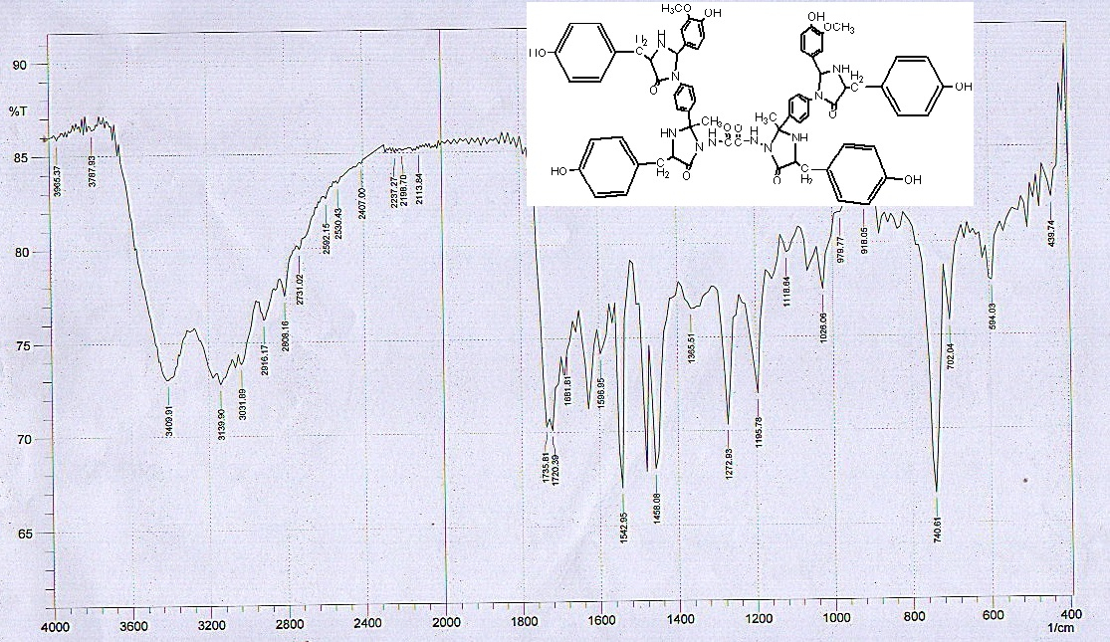

**compound 12**) **N1,N2-bis(4-benzyl-2-(4-(4-benzyl-2-(4-hydroxy-3-methoxyphenyl)-5-oxoimidazolidin-1-yl)phenyl)-2-methyl-5-oxoimidazolidin-1-yl)oxalamide**

was obtained as yellow seram yield 73% , Rf =0.42 .

The infrared spectrum data of compound(12)show absorption at (3055)cm-1 for(Ar-H) ,(3243) cm-1  (N-H),(1453)cm-1  (C-N), and show band at (2969) for (C-H) CH3 (3458) cm-1  for (OH ) (1715) cm-1  (C=O) (18)

The1H-NMR(CDCl3) spectrum data of compound (12) show δ:7-8.1(m,14H,Ar-H) , 6.8(s,4H,NH ,NH), 1.87(m,6H,CH3), 4.77(m,6H,C-H ,OCH3), 5.2(m,8H,C-H ,CH2) 10.77(s,2H,OH ).

The13C-NMR(DMSO) spectrum data of compound (12) show δ: 11.9 (C21) , 13.95 (C1) 59.99(C9,C18) , 77.94 (C8,C17) ,199.99(C10,C19)113.49-159.78(aromating ring)(19)

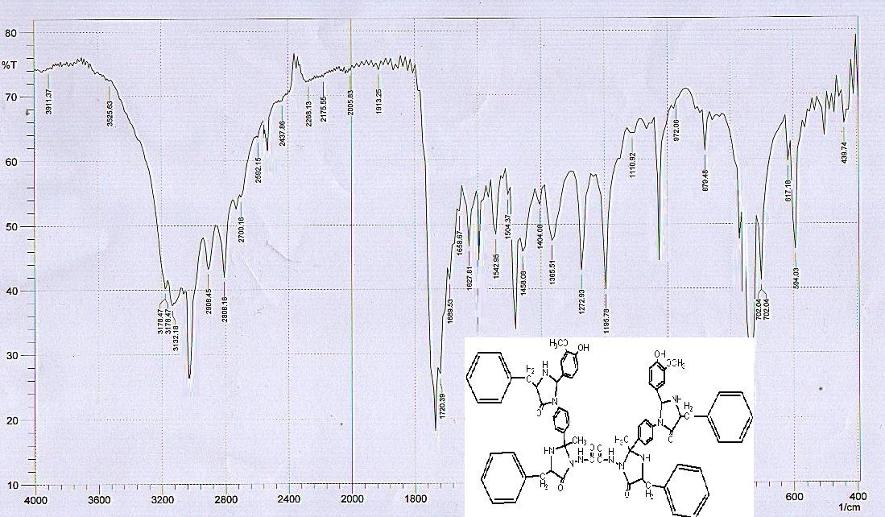

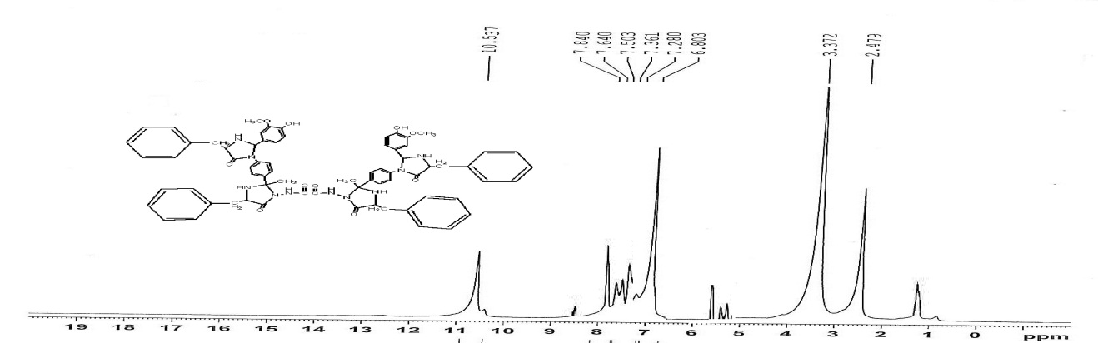

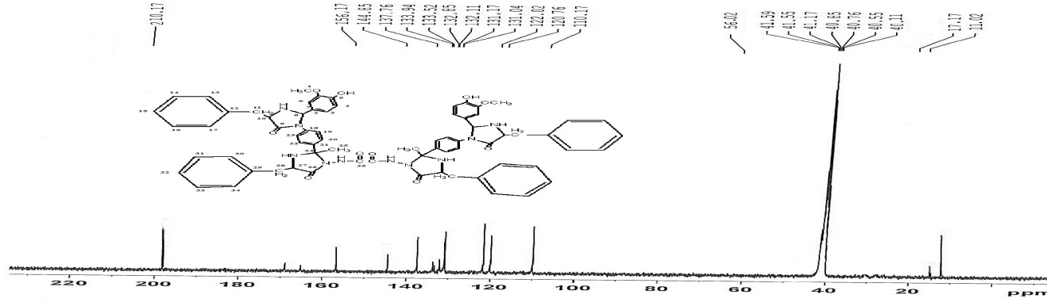

**Table(4):- Analytical and physical data of compounds .**

|  |  |  |  |  |  |  |  |  |
| --- | --- | --- | --- | --- | --- | --- | --- | --- |
| **No.** | **Molecular formula** | **Color** | **M.P°C** | **Yield%** | **Rf** | **C.H.N** | | |
| **C** | **H** | **N** |
| 1 | C2H6N4O2  (118.095) | white | 153-155 | 85 | 0.3 |  |  |  |
| 2 | C18H20N6O2  (352.390) | yellow | 259-260 | 77 | 0.3 | 61.35 | 5.72 | 23.85 |
| 61.29 | 5.67 | 23.80 |
| 3 | C34H32N6O6  (620.654) | orang | 197-199 | 92 | 0.42 | 65.80 | 5.20 | 13.54 |
| 65.24 | 5.29 | 13.67 |
| 4 | C42H36Cl4N6O10  (926.581) | Brown | seram | 79 | 0.35 | 54.44 | 3.92 | 9.07 |
| 53.96 | 3.99 | 9.47 |
| 5 | C42H40N6O10S4  (917.016) | white | 233-234 | 86 | 0.4 | 55.01 | 4. 40 | 9.16 |
| 55.61 | 4. 66 | 9.37 |
| 6 | C66H48N6O18  (1213.117) | yellow | 188-190 | 96 | 0. 38 | 65.34 | 3.99 | 6.93 |
| 65.83 | 4.11 | 6.83 |
| 7 | C50H40N6O18  (1012.882) | yellow | seram | 81 | 0.41 | 59.29 | 3.98 | 8.30 |
| 59.45 | 3.46 | 8.38 |
| 8 | C50H48N6O18  (1020.303) | yellow | 237-238 | 74 | 0.44 | 58.82 | 4.74 | 8.23 |
| 59.02 | 4.79 | 8.34 |
| 9 | C42H44N10O10  (848.860) | orang | 349-250 | 77 | 0.32 | 59.43 | 5.22 | 16.50 |
| 59.33 | 5.67 | 16.23 |
| 10 | C46H52N10O10  (904.966) | orang | 215-217 | 86 | 0.41 | 61.05 | 5.79 | 15.48 |
| 61.75 | 5.25 | 15.53 |
| 11 | C70H68N10O14  (1273.348) | Brown | seram | 80 | 0.3 | 66.03 | 5.38 | 11 |
| 66.83 | 5.30 | 10.74 |
| 12 | C70H68N10O10  (1209.350) | yellow | seram | 73 | 0.42 | 69.52 | 5.67 | 11.58 |
| 69.28 | 5.37 | 11.33 |

**References**

1- Wenling Qin, Mauro Panunzio and Stefano Biondi , *Antibiotics*, *3*, 193-215 , 2014.

**2**- Monika I. Konaklieva , *Antibiotics*, *3*, 128-142 , (2014).

3-Girija S. Singh and Siji Sudheesh , *ARKIVOC* (i) 337-385 , (2014) .

4-Syeda Laila Rubab, Bushra Nisar, Abdul Rauf Raza , Nisar Ullah and Muhammad Nawaz Tahir , *Molecules*, *19*, 139-148, (2014).

5-Dhanya Sunil, Ranjitha C, Rama, Ksr Pai *, IJIRSET***,** 3, 8, (2014).

6-Jialu Luo, Jinlong Wu, Wei-Min Dai, *Diversity Oriented Synth*; 1: 29–34 , (2014).

7-Maria Apotrosoaei , Ioana Mirela Vasincu , Maria Dragan , Frédéric Buron , Sylvain Routier , and Lenuta Profire , *Molecules*, *19*, 13824-13847 , (2014)**.**

8- Tribhuvan Singh*, Deepak Khobragade , *JPSBR*, 4, ,1: (110-113) , (2014).

9-Santosh L. Gaonkar, Namratha, Nitinkumar S. Shetty and Hiroki Shimizu , *Interactive Medicinal Chemistry* , 2(2), (2014).

10-A.Jamal Abdul Nasser ,A.Idhayadhulla ,R.Surendra Kumar and J.Selvin ,*J of Chem.* ,7,1320-1325,(2010) .

11- Yousery E. Sherif1, Sami A. Gabr,Elsayed A. Elmorsy and Ahmad H. Alghadir , *Der Pharma Chemica*, 6 (1):77-84, (2014).

12-Hemali Padalia, Paras Ramavat, Shipra Baluja and Sumitra Chanda , *World Journal of Pharmacy and Pharmaceutical Sciences* , 3( 7), 1473-1479 ,(2014).

13- Ibtisam K. Jassim,Wissam Kh. Jassim, Salwa Abd Alsatar and Abdulla H.Mohammed , *Kerbala Journal of Pharmaceutical Sciences* , 3,( 2012).

14- E. S. El-Tamaty, *Ind. J. Chem.* 35B, 1067 (1996).

15- Panneer Selvam, T, P. P. Radhika, S. Janagaraj1, A. Siva Kumar; *Researchin* *Biotchnology*,2 (3),50-57, (2011).

**16-**P.Selvam , P.P.Radhika , S. *Janagaraj and A.Siva Knmar, J. Resarch in Biotechnology* , 2 (3) : 50-57 **,( 2011).**

**17-**M.S.Magtoof and S.SBari , *Basrah Journal of Scienec* , 24 (1), 95-102 , **(2006)**

18-N.M.Al-Jamali,M.Jameel ,A.A.Alhaidari ,*world J pharm seci* ,1(4),163-167,2013.

19-R.Kalirajan , S.U.Sivakumar, S.Jubie , B.Gowramma and B.Suresh , *International Journal of Chem Tech Research* , (1) ,27-34,(2009) .