
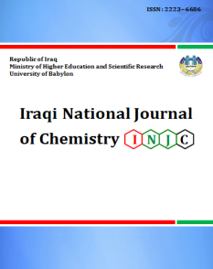
Iraqi National Journal of Chemistry
Journal homepage: http://iqnjc.com/Default.aspx

Synthesis of hetero cyclic compounds pyrazole and pyridiazine from 3-Methylbutane Hydrazide Derivatives with evaluating of its biological activity

Hala Shakyier Lihimes
Department of Chemistry, College of Science, Babylon University

الخلاصة
مثيل) -3- مثيل) بنتوامايد ( -يل4-يل) بايفنيل -5-تترازول H1-2)-N-2-(s) إن تفاعل
(1) تفاعل المركب . (1) بيوتانوك أسد مع الميثانول بوجود حامض الخليك أعطي المركب
مع الانهيدريدات (2)معاملة المشتق (2)مثيل بيوتان ھيدرازايد -3 مع الھيدرازين المائي ينتج
مع(2) ومعاملة المشتق.(3-5) (المالك,السكسنك,الفثالك) أعطى مشتقات جديدة من البيردايزين
وتقيم الفعالية (6-8) استايل اسيتون , اثيل اسيتو استيت يعطى مشتقات جديدة من البايرازول
البايلوجية للبعض منها . وشخصت النواتج بالاعتماد على بعض الخواص الطيفية . IR, ¹HNMR
ABSTRACT
Condensation of (S)-2-(N-((2'-(1H-tetrazol-5-yl)biphenyl-4-yl)methyl)pentanamido)-3-methylbutanoic acid with methanol in acetic acid give methyl (S)-methyl 2-(N-((2'-(1H-tetrazol-5-yl)biphenyl-4-yl)methyl)pentanamido)-3-methylbutanoate compound (1).Reaction of compound(1) with hydrazine hydrate resulted 3-methyl butane hydrazide derivatives (2). Treatmentof(2) with malic anhydride, phthalic anhydride ,succinic anhydride afford pyridiazine derivatives (3-5)and then with acetylacetone, ethylacetoacetate, afford a new derivatives pyrazole compound (6-8) and evaluation of biological activity for some of them. The identification of isolated and purified compounds are elucidated by ¹HNMR, IR.
Key word:- hydrazide, pyrazole, hydrazine, anhydride.
INTRODUCTION
Hydrazide derivatives have been frequently found in heterocyclic chemistry as key intermediates for synthesis of hetero cyclic compound and they have been reported to exhibit biological activity[1].The hydrazide is still used in many fields of chemical and biological as anti-TB or Tuberculosis materials[2],As well as the possibility of its transformation into a five non homogeneous, for example Pyridazine and pyrazole which important biological precious several studies[3,4] .Hydrazines and their derivatives represent an important class of compounds that has found wide utility in organic synthesis [5,6]. While hydrazines have usually been working as reagents for the derivatization and characterization of carbonyl compounds, in recent years the N-N linkage has been used as a key structural design in different bioactive agents. In particular, an increasing number of N-N bond-containing heterocyclic and peptidomimetics have made their way into commercial applications as pharmaceutical and agricultural agents [7,8]. Recently, hydrazide-hydrazones have gained great importance due to their diverse biological properties including antibacterial, antifungal, anticonvulsant, anti-inflammatory, antimalarial and antituberculosis activities [9-21], antimicrobial and potent analgesic [22]. During the past few decades increasing interest in the synthesis and properties of pyridazines, pyridazinones, pyridopyridazines, and pyridopyridazinones has been show wide spectrum of biological activities as described in the literature [23-25]. Both classes of substances are of interest as antiviral and cancer therapies, since their structures and properties look like those of sure present pteridines and purines. Lately pyridazinone nucleus has been extensively studied in the search for new and selective medicinal agents as drugs acting on the cardiovascular system [26,27]. Pyrazoles are chemical compounds of synthetic origin that have a five-membered heterocycle with two nitrogen atoms and three adjacent carbons. Pyridazine derivatives have been reported to possess antimicrobial and potent analgesic, Pyrazole derivatives, several members of the pyrazoles class, have shown good pharmacological effects or have the potential biological activities, such as, anti-inflammatory [28], antiviral [29], antimicrobial [30] , anticonvulsant [31], antitumor [32], fungicidal activities [33] and antihistaminic [34] ,and antibacterial antiviral [35] ,ant diabetic and bactericidal activities[36].
MATERIALS AND METHODS
Melting points were determined in open capillary tubes on Gallen kamp melting point apparatus and are uncorrected . The IR spectra KBr disc were recorded with Shimadzu -2N,FTIR-8400 S, ¹HNMR spectra were determined on Bruker 400 MHz spectrometer using DMSO as solvent.

Synthesis of methyl (S)-methyl 2-(N-((2'-(1H-tetrazol-5-yl)biphenyl-4-yl)methyl)pentanamido)-3-methylbutanoate (1).
(S)-2-(N-((2'-(1H-tetrazol-5-yl)biphenyl-4-yl)methyl)pentanamido)-3-methylbutanoic acid (0.05 mole,4.75 g ) with (0.05 mole, 4.3 ml) from methanol in 10 drops of H₂SO₄was refluxed on steam bath for 4 hrs.,then it poured with stirring into crushed ice . The solid precipitate was filtered washed with cold water dried and recrystallized
from ethanol table (1) .
Synthesis of (S)-N-((2'-(1H-tetrazol-5-yl)biphenyl-4-yl)methyl)-N-(1-hydrazinyl-3-methyl-1-oxobutan-2-yl)pentanamide (2).
To a solution of methyl 3-(pyrimidin -2-yl amino) propanoate(1) (0.01 mole, 1.9 g) in absolute ethanol 50 ml, hydrazine hydrate (0.01mole) was added and the reaction mixture was refluxed for 6 hrs. On cooling, the solid precipitate was filtered off and recrystallized from ethanol table (1) .
Synthesis of (S)-N-((2'-(1H-tetrazol-5-yl)biphenyl-4-yl)methyl)-N-(1-(3,6-dioxo-Aryl -hydropyridazin-1(6H)-yl)-3-methyl-1-oxobutan-2-yl)pentanamide (3,4).
A mixture different anhydride (0.001 mole )(malic anhydride ,succinic anhydride) dissolve in 30 ml of acetic acid with (0.001 mole, 0.19 g ) from compound [2] the mixture was refluxed for 5 hrs., then poured into ice water filtered the precipitate and recrystallized from petroleum ether and acetic acid( 1:1 ) table (1) .

Synthesis of (S)-N-((2'-(1H-tetrazol-5-yl)biphenyl-4-yl)methyl)-N-(1-(1,4-dioxo-3,4-dihydrophthalazin-2(1H)-yl)-3-methyl-1-oxobutan-2-yl)pentanamide (5).
A mixture from phthalic anhydride (0.001 mole, 0.16 g ) with 30ml of acetic acid, (0.001 mole, 0,19 g) from hydrazide [2] the mixture was refluxed for 5 hrs. Then proud into ice water filtered and recrystallized from acetic acid table (1) .
Synthesis of pyrazole derivatives( General procedure) (6,7).
To a mixture of (0.001 mole, 0.191 g ) from hydrazide compound[2] with (0.001 mole ) acetyl acetone, ethylaceto acetate and with 0.1ml acetic acid in 30 ml abslout ethanol ,the mixture was refluxed 5 hrs.Then cooled the precipitate and filtered off ,recrystallized by ethanol table (1) .

Scheme 1

RESULTS AND DISCUSSION
The new derivatives of pyridazin, pyrazole were prepared following the reaction sequences outlined in scheme I.Compound (1) prepared by the reaction of S)-2-(N-((2'-(1H-tetrazol-5-yl)biphenyl-4-yl) methyl) pentanamido)-3-methylbutanoic acid with methanol in acetic acid to give the methyl (S)-methyl 2-(N-((2'-(1H-tetrazol-5-yl)biphenyl-4-yl)methyl)pentanamido)-3-methylbutanoate. The IR spectra have been studied and were in agreement with the required structure. IR. (cm⁻¹) of compound [1] show of several bands (1738 cm⁻¹) stretching band of C=O of ester. Treatment of compound [1] with hydrazine hydrate in absolute ethanol gave the key intermediate hydrazide compound [2]. The IR. Spectra show decrease frequency of carbonyl group at (1738cm⁻¹)to(1646 cm⁻¹) and appearance band at(3369cm⁻¹) stretching band of NH. The ¹H NMR (DMSO_d6) of compound [2] : 6.5(d, 4H , CH aromatic ), 6.4(t, 2H , CH aromatic ), 8.5 (s , 1H,NH) , 1.4 , 1.5 (2t, 2(2H), CH₂CH₂) ,4.2 (s, 2H, CH₂), 2.2 (d, 2H, CH₂),5.3 (s ,2H,NH₂), 2.0 (3s , 3(3H), CH₃).
Pyridazine derivatives have been preparation by treatment of 3-methyl butane hydrazide [2] with (maleic anhydride, succinic anhydride and phthalic anhydride ) in acetic acid giving the derivatives of pyridazine compounds [3,4,5].The IR. Spectra appearance the band of (O-H) at (3464cm⁻¹). Pyridazine ring appearance at band (1745cm⁻¹) , and the band (1674-1640 cm⁻¹) was due to the V(C=O)of amide this value appear to be lower than expected due to the hydrogen bond between it and (N-H) group of pyridazine ring. From the above mentioned results we can say that the compound [3,4and 5] can be exist in two tautomeric forms; keto [I] and enol [II] forms.

The ¹H NMR(DMSO_d6) of compound [3]: 6.3d, 4H , C-H aromatic ), 6.2t, 2H , CH aromatic ), 8.2(s , 1H,NH) , 1.4 , 1.5 (2t, 2(2H), CH₂CH₂) , 4.2 (s, 2H, CH₂), 2.2 (d, 2H, CH₂), 2.0 (3s , 3(3H), CH₃). 10.1(s,1H, NH pyridazin), 6.8,7.2 (2d,2(1H), CH=CH).Condensation of compound [2] with (acetyl acetone and ethyl aceto acetate) in absolute ethanol in catalytic amount acetic acid gave the derivatives of pyrazoles compounds [6,7]. The IR Spectra presence the band at (1763-1701 cm⁻¹)and (1660-1626 cm⁻¹)(C=O) of pyrazole ring .¹H NMR (DMSO_d6) of compound [6] :6.9 (d,4H, aromatic proton ), 9.1(s,1H,NH), 1.6,1.2 (2t,2(2H), CH₂CH₂),2.7,2.5 (2s , 2(3H), CH₃), 2.0 (3s , 3(3H), CH₃).

Table 1: physical properties of compounds.
M.Wt  g mole-1 | Molecular  formula | Recrysitlazition | Mp.  C0 | Yield  % | Compound | NO.
449 | C25H31N5O3 | Ethanol | 130-133 | 75 % |  | 1
449 | C24H31N7O2 | Ethanol | 148-150 | 75 % |  | 2
529 | C28H31N7O4 | Petroleum ether  and acetic acid | 192-194 | 70 % |  | 3
531 | C28H33N7O4 | Petroleum ether and acetic acid | 200-204 | 70 % |  | 4
579 | C32H33N7O4 | Acetic acid | 208-211 | 75 % |  | 5
513 | C29H35N7O2 | Ethanol | 214-216 | 75 % |  | 6
515 | C27H33N7O3 | Ethanol | 165-167 | 70 % |  | 7
Table 2: Spectral data.

Others  cm-¹ | V (C=C)  cm⁻¹ | V(C=N)  cm-¹ | V(C=O)  cm-¹ | V(C-H) cm-¹ aliphatic | V(C-H)  cm-¹  aromatic | Compound  NO.
V (C-O) ester  1320 | 1476 | 1602 | 1738  ester | 2986  2935 | 3061 | 1))
V (N-H)  3369 | 1531 | 1620 | 1646 | 2998  2975 | 3178 | 2))
V(OH)  3506 | 1521 | 1598 | 1730  1674 | 2993  2935 | 3101 | 3))
V(OH)  3509 | 1512 | 1595 | 1705  1660 | 2978  2920 | 3031 | 4))
V(OH )  3456 | 1531 | 1595 | 1745  1653 | 2985 | 3234 | 5))
- | 1475 | 1609 | 1763  1716 | 2925  2850 | 3106 | 6))
V(OH )  3482 | 1572 | 1609 | 1701  1626 | 2941  2850 | 3107 | 7))

Table 3: Chemical shifts H¹NMR spectra

Remarks | No. of proton | Type of  signal | Chemical  shift(S) ppm. | Compound  NO.
Due to aromatic proton.  Due to NH proton.  Due to CH2CH2 proton  Due to CH2 proton  Due to NH2 proton.  Due to CH3proton  Due to CH proton | 4H,2H,2H  1H  2H,2H  2H,2H,2H  2H  9H  1H | d,t,d  s  t,t  s,d,t  s  s  t | 6.5,6.4,6.2  8.5  1.4,1.5  4.2,4.4, 2.2  5.3  2.0  2.5 | 2
Due to aromatic proton.  Due to NH proton.  Due to CH2CH2 proton  Due to CH2 proton  Due to NH pyridazin.  Due to CH=CH proton  Due to CH3proton  Due to CH proton | 4H,2H,2H  1H  2H,2H  2H,2H,2H  1H  1H,1H  9H  1H | d,t,d  s  t,t  s,d,s  s  d,d  s  s | 6.3,6.2,6.5  8.2  1.3,1.6  4.4,2.4,4.2  10.1  6.8,7.2  1.9  2.5 | 3
Due to aromatic proton.  Due to NH proton  Due to CH2CH2 proton  Due to CH3proton  Due to CH3proton  Due to CH2 proton  Due to CH proton | 4H,2H,2H  1H  2H,2H  3H,3H  9H  2H,2H,2H  1H | d,t,d  s  t,t  s,s  s  s,d,s  s | 6.3,6.5,6.9  9.1  1.6,1.2  2.5,2.7  2.0  4.4,2.2,4.2  2.4 | 6

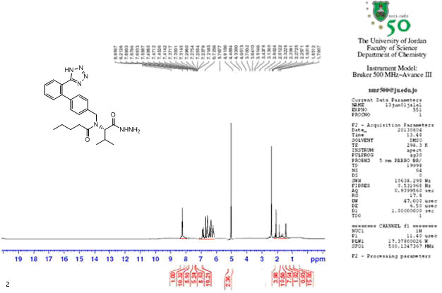

Figure(1) H1NMR of (S)-N-((2'-(1H-tetrazol-5-yl)biphenyl-4-yl)methyl)-N-(1-hydrazinyl-3-methyl-1-oxobutan-2-yl)pentanamide.

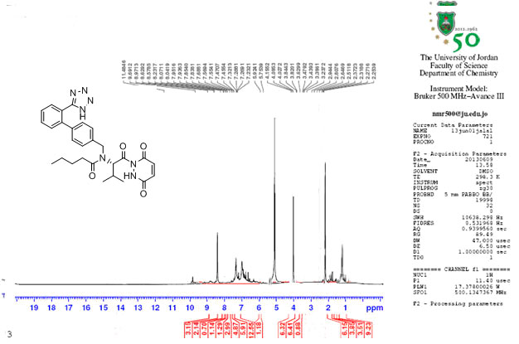

Figure(2) H1NMR of (S)-N-((2'-(1H-tetrazol-5-yl)biphenyl-4-yl)methyl)-N-(1-(3,6-dioxo-2,3-dihydropyridazin-1(6H)-yl)-3-methyl-1-oxobutan-2-yl)pentanamide

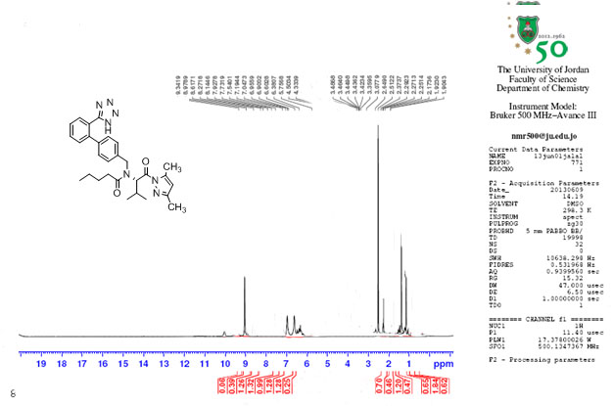
Figure(3) H1NMR of (S)-N-((2'-(1H-tetrazol-5-yl)biphenyl-4-yl)methyl)-N-(1-(3,5-dimethyl-1H-pyrazol-1-yl)-3-methyl-1-oxobutan-2-yl)pentanamide.

Biological Activity:
Here in this work, the sensitivity test was performed according to the Kerby –Bauer method. Compound (5) was assayed for its antimicrobial activity in vitro against Gram-negative bacteria (Escherichia coli) and Gram-positive bacteria (staphylococcus aurous). Prepared agar and Petri dishes were sterilized by autoclaving for 15min at 121C°. DMSO was used as a solvent. These plates were incubated at 37C° for 24h for both bacteria. The inhibition zones caused by the various compounds were examined. The results of the preliminary screening tests are listed in table (4).
The biological activity test showed that compounds with free (-NH2) groups having a biological effect on each of E.Coli and Staph.aureus, these compounds are also considered biologically active on bacteria .
Table (4): inhibition zooms for prepared compounds (1-7).
St. aureus | Ps. aeruginosa | Comp.No.
+- | + | 1
+ | + | 2
+- | ++ | 3
+- | + | 4
+ | ++ | 5
- | ++ | 6
- | + | 7

inhibition = (-) (5-10) mm = (+) , (11-20) mm = ++ , more than (20)mm =+

REFRENCES
1. Chernkh,V.P.,Kabehnyi,V.J.,Shapova,V.A.,Poroknyah,L.A.,Beletsk
aka,O.V.and Savchenko,V.N, khim.farm (1989), 828.
4. Aboul-Fadl , T. , Radwan , A. A. ,Aabdlazez, H. , Baseeruddin , M ., Attia, M. I. and, Kadi, A. . 2012 .7 (1) : 329- 338 .
5.Husain, A. and Ajmal, M., Acta Pharm, 2009 ,59 (2) : 223-233 .
6. Jaiswal, N., Sing, A. K. , Singh, D.and Ahmad, T. , Intr. Res.J. Pharm. 2012.
3 (3) : 83-89 .
7 . Rallas, S.; Gulerman, N.; Erdeniz, H. Farmaco 2002, 57, 171-174.
8. Gursoy, A.; Terzioglu, N.; Otuk, G. , Eur. J. Med. Chem. 1997, 32, 753-757.
9. Vicini, P.; Zani, F.; Cozzini, P.; Doytchinova, I. , Eur. J. Med. Chem. 2002, 37, 553-564.
10. Mamolo, M.G.; Falagiani, V.; Zampieri, D.; Vio, L.; Banfo, E.
IIFARMACO 2001, 56, 587-592.
9. Rahman, V.M.; Mukhtar, S.; Ansari, W.H.; Lemiere, G. , Eur. J. Med. Chem. 2005, 40, 173-184.
10. Dimmock, J.R.; Vashishtha, S.C.; Stables, J.P. , Eur. J. Med. Chem. 2000, 35, 241-248.
11. Yapia, R.; La Mara, M.P.; Massieu, G.H. ,. Pharmacol. 1967, 16, 1211-1218.
12. Sava, G.; Perissin, L.; Lassiani, L.; Zabucchi, G. ,. Chem. Biol. Interact., 1985,
53, 37-43.
13. Xia, Y.L; Chuan-Dong, F.; Zhao, B.X.; Zhao, J.; Shin, D.S.; Miaom J.Y. , Eur. J. Med. Chem. 2008, 43, 2347-2353.
14. Melnyk, P.; Leroux, V.; Serghergert, C.; Grellier, P. Design, ,. Med. Chem. Lett. 2006, 16, 31-35.
15. Ajani, O.O.; Obafemi, C.A.; Nwinyi, O.C.; Akinpelu, D.A. , Bioorg. Med. Chem. 2010, 18,214-221.
16 . Zheng, L.W.; Wu, L.L.; Zhao, B.X.; Dong, W.L.; Miao, Y.J. ,Med. Chem. 2009, 17, 1957-1962.
17. Bhagavan, N.V. Medical Biochemistry; Elsevier Science B.V.: Amsterdam, The Netherlands,2002; Volume 17, pp. 331-363.
18. Saulnier, M.G.; Velaprthi, U.; Zimmermann, K. In Progress In Heterocyclic Synthesis; Gribble,G., Ed.; Elsevier Science B.V.: Amsterdam, The Netherlands, 2005; Volume 16, pp. 228-271.
19. D. S. Dogruer ,S. Urlu, T. Onkol ,B. Ozcelik, M. Fethi, Turk J .Chem . (2010) 34 , 57 – 65.
20. Holdiness, M.R. A review of blood dyecrasias induced by the antituberculosis drugs. Tubercle ,1987, 68, 301-309.
21. Faroumadi, A.; Kiano, Z.; Soltani, F. ,Farmaco 2003, 58, 1073-1076.
22. Mohammad Asifand Anita Singh"Exploring potential synthetic methods pyridazinone",(2010),2.(2), 1112-1128.
23. Oka, Y.; Omura, K.; Miyake, A.; Itoh, K.; Tomimoto, M.; Tada, N.; Yurugi, S.
Chem. Pharm. Bull. 1975, 23, 2239 and references within.
24. Tigler, M.; Stanovnik, B. Azolo- and Azinopyridazines and Some Oxa and Thia
Analogs. In Condensed Pyridazines Including Cinnolines and Phthalazines;
Castle, R. N. Ed.; John Wiley & Sons, Inc.: New York, 1973; pp. 968-1012 and
references within.
25. Kricka, L. Pure Appl. Chem., 1996,68 (I 0). 1825- 1830.
26 . Frank, H.; Heinisch, G. Pharmacologically Active Pyridazines Part I. In Progress
in Medicinal Chemistry, Ellis, G.P., West, G. B., Eds.; Elsevier: Amsterdam,
1990; Vol 27, 1.
27. Frank, H.; Heinisch, G. Pharmacologically Active Pyridazines Part II. In
Progress in Medicinal Chemistry, Ellis, G.P., Luscombe, D.K., Eds.; Elsevier:
Amsterdam, 1992; Vol 29, 141.
28. A. K. Tewari and A. Mishra, Bioorg. Med. Chem. , 2001, vol. 9, pp. 715-718.
29. S. L. Janus, A. Z. Magdif, B. P. Erik, and N. Claus, Monatsh. Chem. , 1999, vol. 130, pp. 1167-1174.
30. E. V. Pimerova and E. V. Voronina, Pharm. Chem. J., 2001,vol. 35, pp. 602-604.
31. I. Bouabdallah, L. A. Barret, A. Zyad, A. Ramadan, I. Zidane, and A.Melhaoui, Nat. Prod.Res. , 2006, vol. 20, pp. 1024-1030.
32. H. J. Park, K. Lee, S. J. Park, B. Ahn, J. C. Lee, H. Y. Cho, and K. I. Lee,
Med. Chem. Lett. , 2005, vol. 15, pp. 3307-3312.
33. C. K. Chu and J. J. Cutler, Heterocycl. Chem. , 1986, vol. 23, pp. 289-319.
34. V. Michon, C. H. Du Penhoat, F. Tombret, J. M. Gillardin, F. Lepagez,
and L. Berthon, Eur. J. Med.Chem. , 1995, vol. 30, pp. 147-155.
35. R. Kalirajan, Leela Rathore, S. Jubie, B. Cowramma, S. Gomathy,S. Sankar and K. Elango ,Indian J. Pharm. Educ. Res ,(2010),4 (44).
36. Nada M. Abunada, Hamdi M Hassaneen, Nadia G. Kandile and Omar A. Miqdad , .J Molecules,(2008) ,13:1501-1517 .

